

Darshan University

A Project Report on

**“Auction Management System”**

Under the subject

**Software Engineering (2301CS405)**

B. Tech, Semester – IV

Computer Science & Engineering Department

|  |  |
| --- | --- |
| Submitted By | |
| Student Name: Dhruv R. Pithwa | Enrolment No.: 24010101675 |
| Academic Year  (2024-2025) | |
| Internal Guide  Prof. R. B. Gondaliya  Darshan University | Dean-DIET  Dr. Gopi Sanghani  Darshan University |

|  |  |
| --- | --- |
|  | **Computer Science & Engineering Department**  **Darshan University** |

**DECLARATION**

We hereby declare that the SRS, submitted along with the **Software Engineering** **(2301CS405)** for entitled **“Auction Management System”** submitted in partial fulfilment for the Semester-5 of **Bachelor Technology (B. Tech)** in **Computer Science and Engineering (CSE)** Departmentto Darshan University, Rajkot, is a record of the work carried out at **Darshan University, Rajkot** under the supervision of R. B. Gondaliya and that no part of any of report has been directly copied from any students’ reports, without providing due reference.

Dhruv R. Pithwa

Student’s Signature

Date: __________

|  |  |
| --- | --- |
|  | **Computer Science & Engineering Department**  **Darshan University** |

**CERTIFICATE**

This is to certify that the SRS on **“Auction Management System” has** been satisfactorily prepared by **Dhruv R. Pithwa** (**24010101675**) under my guidance in the fulfillment of the course **Software Engineering (2301CS405)** work during the academic year 2024-2025.

|  |  |  |
| --- | --- | --- |
| Internal Guide  Prof. R. B. Gondaliya  Darshan University |  | Dean-DIET  Dr. Gopi Sanghani  Darshan University |

**Acknowledgement**

I wish to express my sincere gratitude to my project guide Prof. R. B. Gondaliyaand all the faculty members for helping me through my project by giving me the necessary suggestions and advices along with their valuable co- ordination in completing this work.

I also thank my parents, friends and all the members of the family for their precious support and encouragement which they had provided in completion of my work. In addition to that, I would also like to mention the Darshan University personals who gave me the permission to use and experience the valuable resources required for the project from the University premises.

Thus, in conclusion to the above said, I once again thank the faculties and members of **Darshan University** for their valuable support in completion of the project.

Thanking You

**Dhruv R. Pithwa**

**ABSTRACT**

This Software Requirements Specification outlines the development of an internet-based Auction Management System designed to streamline online auctions. The system supports multiple user roles—Bidders, Sellers, Guests, Auction Managers, Customer Support, and Drivers—offering functionalities such as auction creation, bidding, real-time updates, dispute resolution, and delivery tracking. Key features include secure account management with two-factor authentication, wallet integration, and intuitive auction browsing with filters. The system ensures usability, accuracy, 24/7 availability, and maintainability, catering to an efficient and transparent online auction marketplace.

**Table of Contents**

List of Figures I

List of Tables II

1 Introduction 1

1.1 Product perspective 1

1.2 Product features 1

1.2.1 User Roles 1

1.2.2 Features for bidder 1

1.2.3 Features for Seller 1

1.2.4 Shared Features for Members (Bidders and Sellers) 1

1.2.5 Features for Guest 1

1.2.6 Features for Auction Manager 2

1.2.7 Features for Customer Support 2

1.2.8 Features for Driver 2

1.3 Functional Requirement 2

1.3.1 Bidder 2

1.3.2 Seller 2

1.3.3 Member (Bidder and Seller Shared Functions) 2

1.3.4 Guest 2

1.3.5 Auction Manager 2

1.3.6 Customer Support 3

1.3.7 Driver 3

1.4 Non-Functional Requirement 3

1.4.1 Usability: 3

1.4.2 Accuracy: 3

1.4.3 Availability: 3

1.4.4 Maintainability: 3

2 Design and Implementation Constraints 4

2.1 Use case diagram 4

2.2 Activity diagram and Swimlane diagram 6

2.2.1 Activity diagram and Swimlane diagram for Creating Auction 6

2.2.2 Activity diagram for Placing a Bid 8

2.3 Sequence diagram 9

2.3.1 Sequence diagram for Creating Auction 9

2.3.2 Sequence diagram for Searching Auctions and Placing a Bid 10

2.4 State diagram 11

2.4.1 State diagram of Auction 11

2.4.2 State diagram of Bid 12

2.5 Class diagram 13

2.6 Data flow diagram 14

2.6.1 Context diagram (level-0) 14

2.6.2 DFD Level-1 15

2.6.3 DFD Level-2 15

3 External interface requirement (Screens) 16

3.1 Screen-1: Auction Listing 16

3.2 Screen-2: Auction Details 17

3.3 Screen-3: Bidder Dashboard 18

3.4 Screen-4: Seller's Auction Creation Form 19

3.5 Screen-5: Admin Dashboard 20

4 Database design 21

4.1 List of Tables 21

5 Stories and Scenario 23

5.1 Story-1: Place a Bid on an Auction 23

5.1.1 Scenario# S1.1 23

5.1.2 Scenario# S1.2 23

5.2 Story-2: Create an Auction Listing 23

5.2.1 Scenario# S2.1 23

5.2.2 Scenario# S2.2 24

5.3 Story-3: Approve an Auction Listing 24

5.3.1 Scenario# S3.1 24

5.3.2 Scenario# S3.2 24

6 Test cases 25

7 References 28

# List of Figures

Figure 2.1-1 Use case diagram for Auction Management System 4

Figure 2.1-2 Use case diagram for Auction Management System 5

Figure 2.2.1-1 Activity diagram for Creating Auction 6

Figure 2.2.1-2 Swimlane diagram for Creating Auction 7

Figure 2.2.2 Activity diagram for Placing a Bid 8

Figure 2.3.1 Sequence diagram for Creating Auction 9

Figure 2.3.2 Searching Auctions and Placing a Bid 10

Figure 2.4.1 State diagram of Auction 11

Figure 2.4.2 State diagram of Bid 12

Figure 2.5 Class diagram for Auction Management System 13

Figure 2.6.1 Context diagram (level-0) for Auction Management System 14

Figure 2.6.2 Data flow diagram level-1 for Auction Management System 15

Figure 2.6.3 Data flow diagram level-2 for Auction Management System 15

Figure 3.1 Screen-1: Auction Listing Page 16

Figure 3.2 Screen-2: Auction Details Page 17

Figure 3.3 Screen-3: Bidder Dashboard 18

Figure 3.4 Screen-4: Seller's Auction Creation Form 19

*Figure 3.5 Screen-5: Admin Dashboard* 20

# List of Tables

Table 3.1: Screen-1: Auction Listing Screen element of Auction Listing Page 16

Table 3.2: Screen-2: Auction Details Screen element of Auction Details Page 17

Table 3.3: Screen-3: Bidder Dashboard Screen element of Bidder Dashboard 18

Table 3.4: Screen-4: Seller's Auction Creation Form Screen element of Seller's Auction Creation Form 19

Table 3.5: Screen-5: Admin Dashboard Screen element of Admin Dashboard 20

Table 4.1: Schema of User 21

Table 4.2: Schema of Bidder 21

Table 4.3: Schema of Transaction 21

Table 4.4: Schema of Auction 22

Table 4.5: Schema of Bid 22

# Introduction

## Product perspective

This project aims to develop an internet-based auction management system that replaces traditional manual auction processes with a digital platform. The system enables users to participate in auctions remotely, manage their accounts, and track transactions and deliveries seamlessly. It is a multi-user application designed to support various roles, including Buyers (Bidders), Sellers, Guests, Auction Managers, Customer Support, and Drivers. The system handles core auction-related functions such as auction creation, bidding, approval, dispute resolution, and delivery tracking. It is intended to cater to the needs of an online auction marketplace, ensuring efficiency, transparency, and user satisfaction.

## Product features

### User Roles

### The system supports six distinct user types, each with specific functionalities:

* **Bidder:** Buyers who participate in auctions by placing bids.
* **Member:** who will be accessing the library.
* **Guest:** who will request for membership.
* **Auction Manager:** Administrators who oversee auction operations.
* **Customer Support:** Staff who assist users with issues.
* **Driver:** Personnel responsible for delivering auctioned items.

### Features for bidder

* Browse ongoing auctions with filters (e.g., category, price, rating).
* View auction listings, including item photos, names, descriptions, and current bid prices.
* Place bids higher than the current bid amount.
* Increase bid amounts on active auctions.
* Retrieve (cancel) a bid within 30 seconds of placing it.
* Receive real-time notifications about auction updates and outcomes.
* Bid on multiple auctions simultaneously.
* Manage a wallet for deposits, withdrawals, and transaction history.
* Track delivery status of won items.

### Features for Seller

* Create auction listings with titles, descriptions, and item details.
* Upload photos of items for auction.
* Set initial bid prices for items.
* Define auction duration using a start and end timestamp.
* Publish auctions for bidders to participate.
* Manage a wallet for tracking earnings and transactions.

### Shared Features for Members (Bidders and Sellers)

* Sign up with email or phone, verified via email/SMS.
* Log in with validated credentials; reset passwords via email/SMS.
* Enable two-factor authentication (2FA) for enhanced security.
* Set up profiles with name, profile picture, interests, and role (buyer/seller).

### Features for Guest

* Browse ongoing and past auctions without logging in.
* Search auctions using filters (e.g., category, price, rating).
* Receive prompts to sign up for full access (bidding or selling).

### Features for Auction Manager

* Review and approve seller auction submissions.
* Monitor auctions and pause or stop them if necessary.
* Access a dashboard with auction activity and trends.
* Manage user accounts (e.g., warn or block buyers/sellers).
* Resolve disputes between buyers and sellers.

### Features for Customer Support

* Respond to user help requests and troubleshoot issues.
* Provide real-time assistance via live chat.
* Track and resolve support tickets.
* Maintain a FAQ section with common solutions.

### Features for Driver

* View delivery details (e.g., item, destination).
* Access optimized delivery routes.
* Update delivery status (e.g., picked up, in transit, delivered).
* Contact buyers or sellers directly if needed.

## Functional Requirement

### Bidder

* **Place Bid:** Submit a bid amount exceeding the current highest bid.
* **Increase Bid:** Adjust an existing bid to a higher amount.
* **Retrieve Bid:** Cancel a bid within 30 seconds of placement.
* **Auction Updates:** Receive real-time notifications about bid status and auction results.
* **Multi-Bidding:** Place bids on multiple auctions concurrently.
* **Delivery Tracking:** Monitor the status of item deliveries post-auction.

### Seller

* **Set Auction Details:** Input auction title, description, and item specifics.
* **Upload Item Photo:** Add an image to the auction listing.
* **Set Item Price:** Define the starting bid amount.
* **Set Time:** Specify auction duration with start and end timestamps.
* **Publish Auction:** Launch the auction for bidding.

### Member (Bidder and Seller Shared Functions)

* **Account Creation:** Register using email or phone, confirmed via email/SMS.
* **Login:** Authenticate with credentials, reset password via email/SMS.
* **Two-Factor Authentication:** Activate 2FA for secure access.
* **Profile Setup:** Configure profile with name, photo, interests, and role.
* **Wallet Management:** Link a bank account, create a wallet, deposit/withdraw funds, and view transaction history.
* **Auction Browsing:** Explore auctions with filters (category, price, rating).
* **Auction Listing:** View detailed auction information (photo, name, description, bid price).

### Guest

* **Browse Auctions:** View ongoing and past auctions without authentication.
* **Search & Filter:** Search auctions by category, price, or rating.
* **Sign Up Prompt:** Display registration prompts to encourage account creation.

### Auction Manager

* **Approve Auctions:** Validate and approve seller-submitted auctions.
* **Monitor Auctions:** Pause or terminate auctions if issues arise.
* **Track Data:** Access auction statistics and trends via a dashboard.
* **Manage Users:** Issue warnings or block users for policy violations.
* **Handle Disputes:** Mediate and resolve conflicts between bidders and sellers.

### Customer Support

* **Help Requests:** Address user inquiries and technical issues.
* **Chat Support:** Provide live chat assistance.
* **Track Issues:** Manage support tickets through resolution.
* **FAQs:** Develop and update a knowledge base of common questions.

### Driver

* **Delivery Details:** Retrieve details of items and delivery locations.
* **Routes Made Easy:** Access optimized delivery routes.
* **Update Status:** Log delivery progress (picked up, in transit, delivered).
* **Contact Info:** Obtain contact details for buyers/sellers.

## Non-Functional Requirement

### Usability:

* The user interface must be intuitive and user-friendly, requiring no specialized training.
* Support for multiple languages can be implemented based on user demographics.

### Accuracy:

* Auction data (e.g., bid amounts, transaction records) and delivery statuses must be accurate, consistent, and reliable.
* Real-time updates must reflect the correct auction state without delays.

### Availability:

* The system should be available 24/7 to support online auctions across time zones.
* Downtime recovery should occur within 30 minutes or less.
* Responses to user actions (e.g., bid placement, page loading) must occur within two seconds.

### Maintainability:

* The software must be easily maintainable, allowing for quick updates or feature additions.
* It should be portable, adaptable to various devices (e.g., web, mobile) and platforms with minimal reconfiguration.

# Design and Implementation Constraints

## Use case diagram

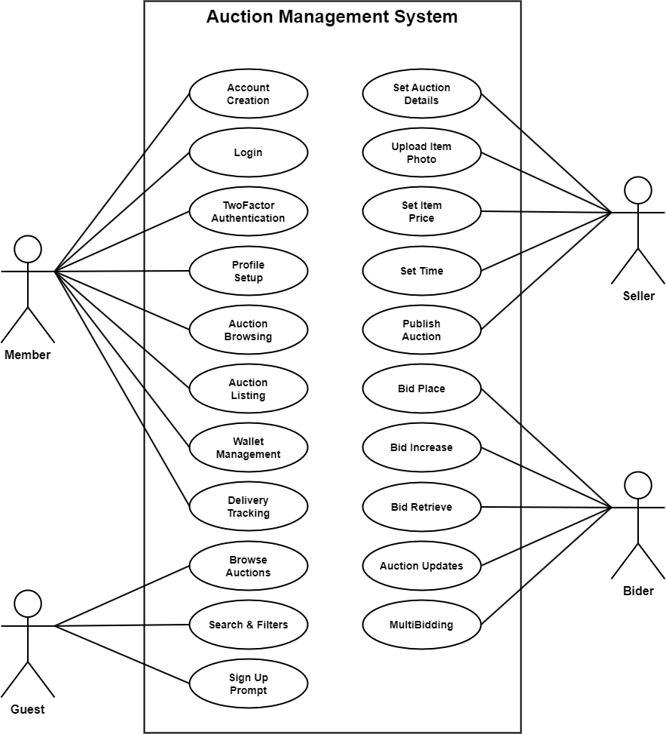

Figure 2.1-1 Use case diagram for Auction Management System

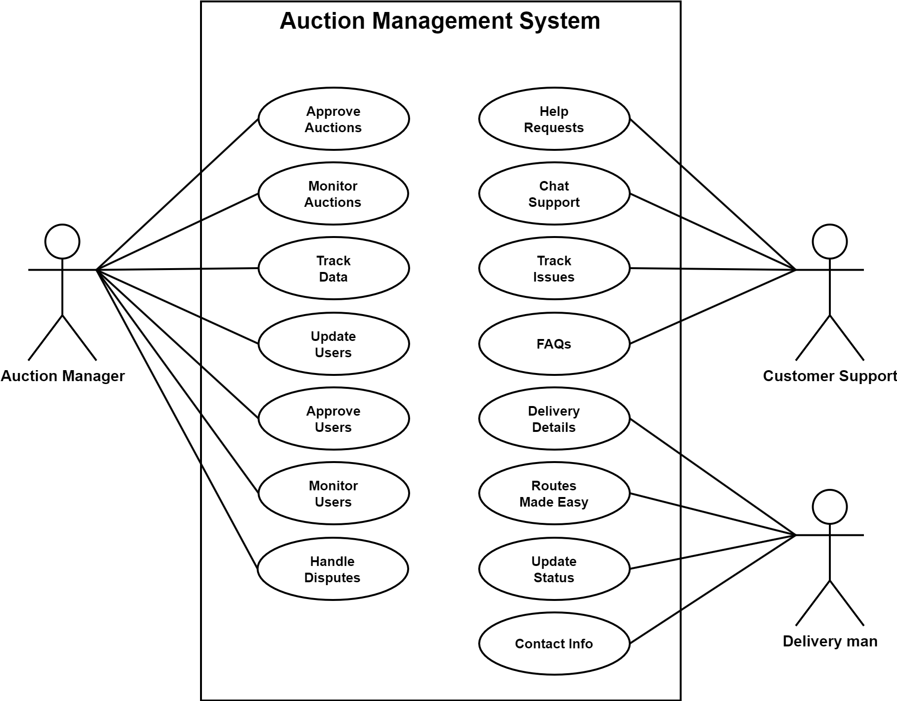

Figure 2.1-2 Use case diagram for Auction Management System

## Activity diagram and Swimlane diagram

### Activity diagram and Swimlane diagram for Creating Auction

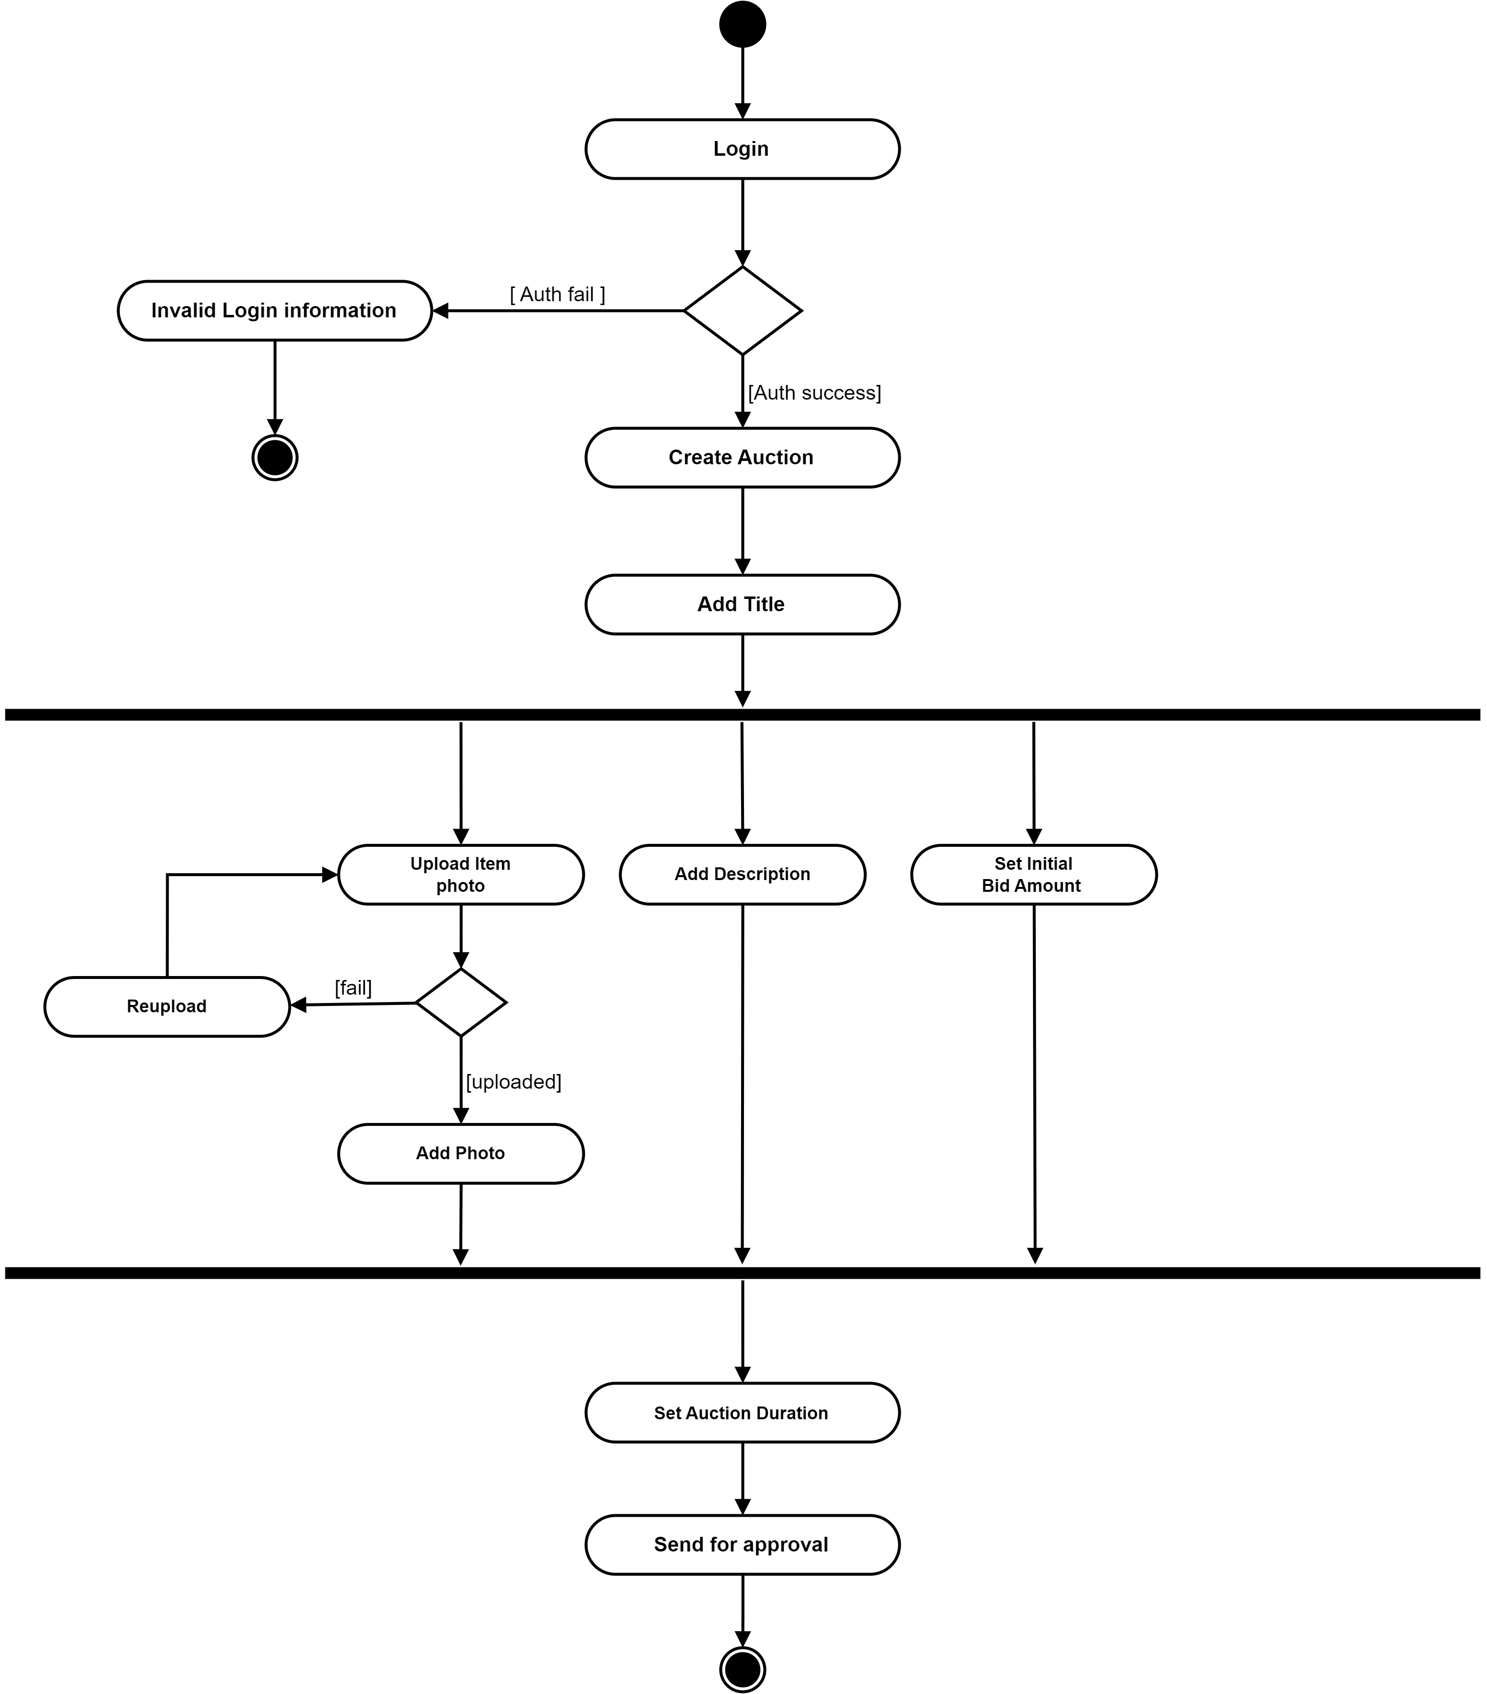

Figure 2.2.1-1 Activity diagram for Creating Auction

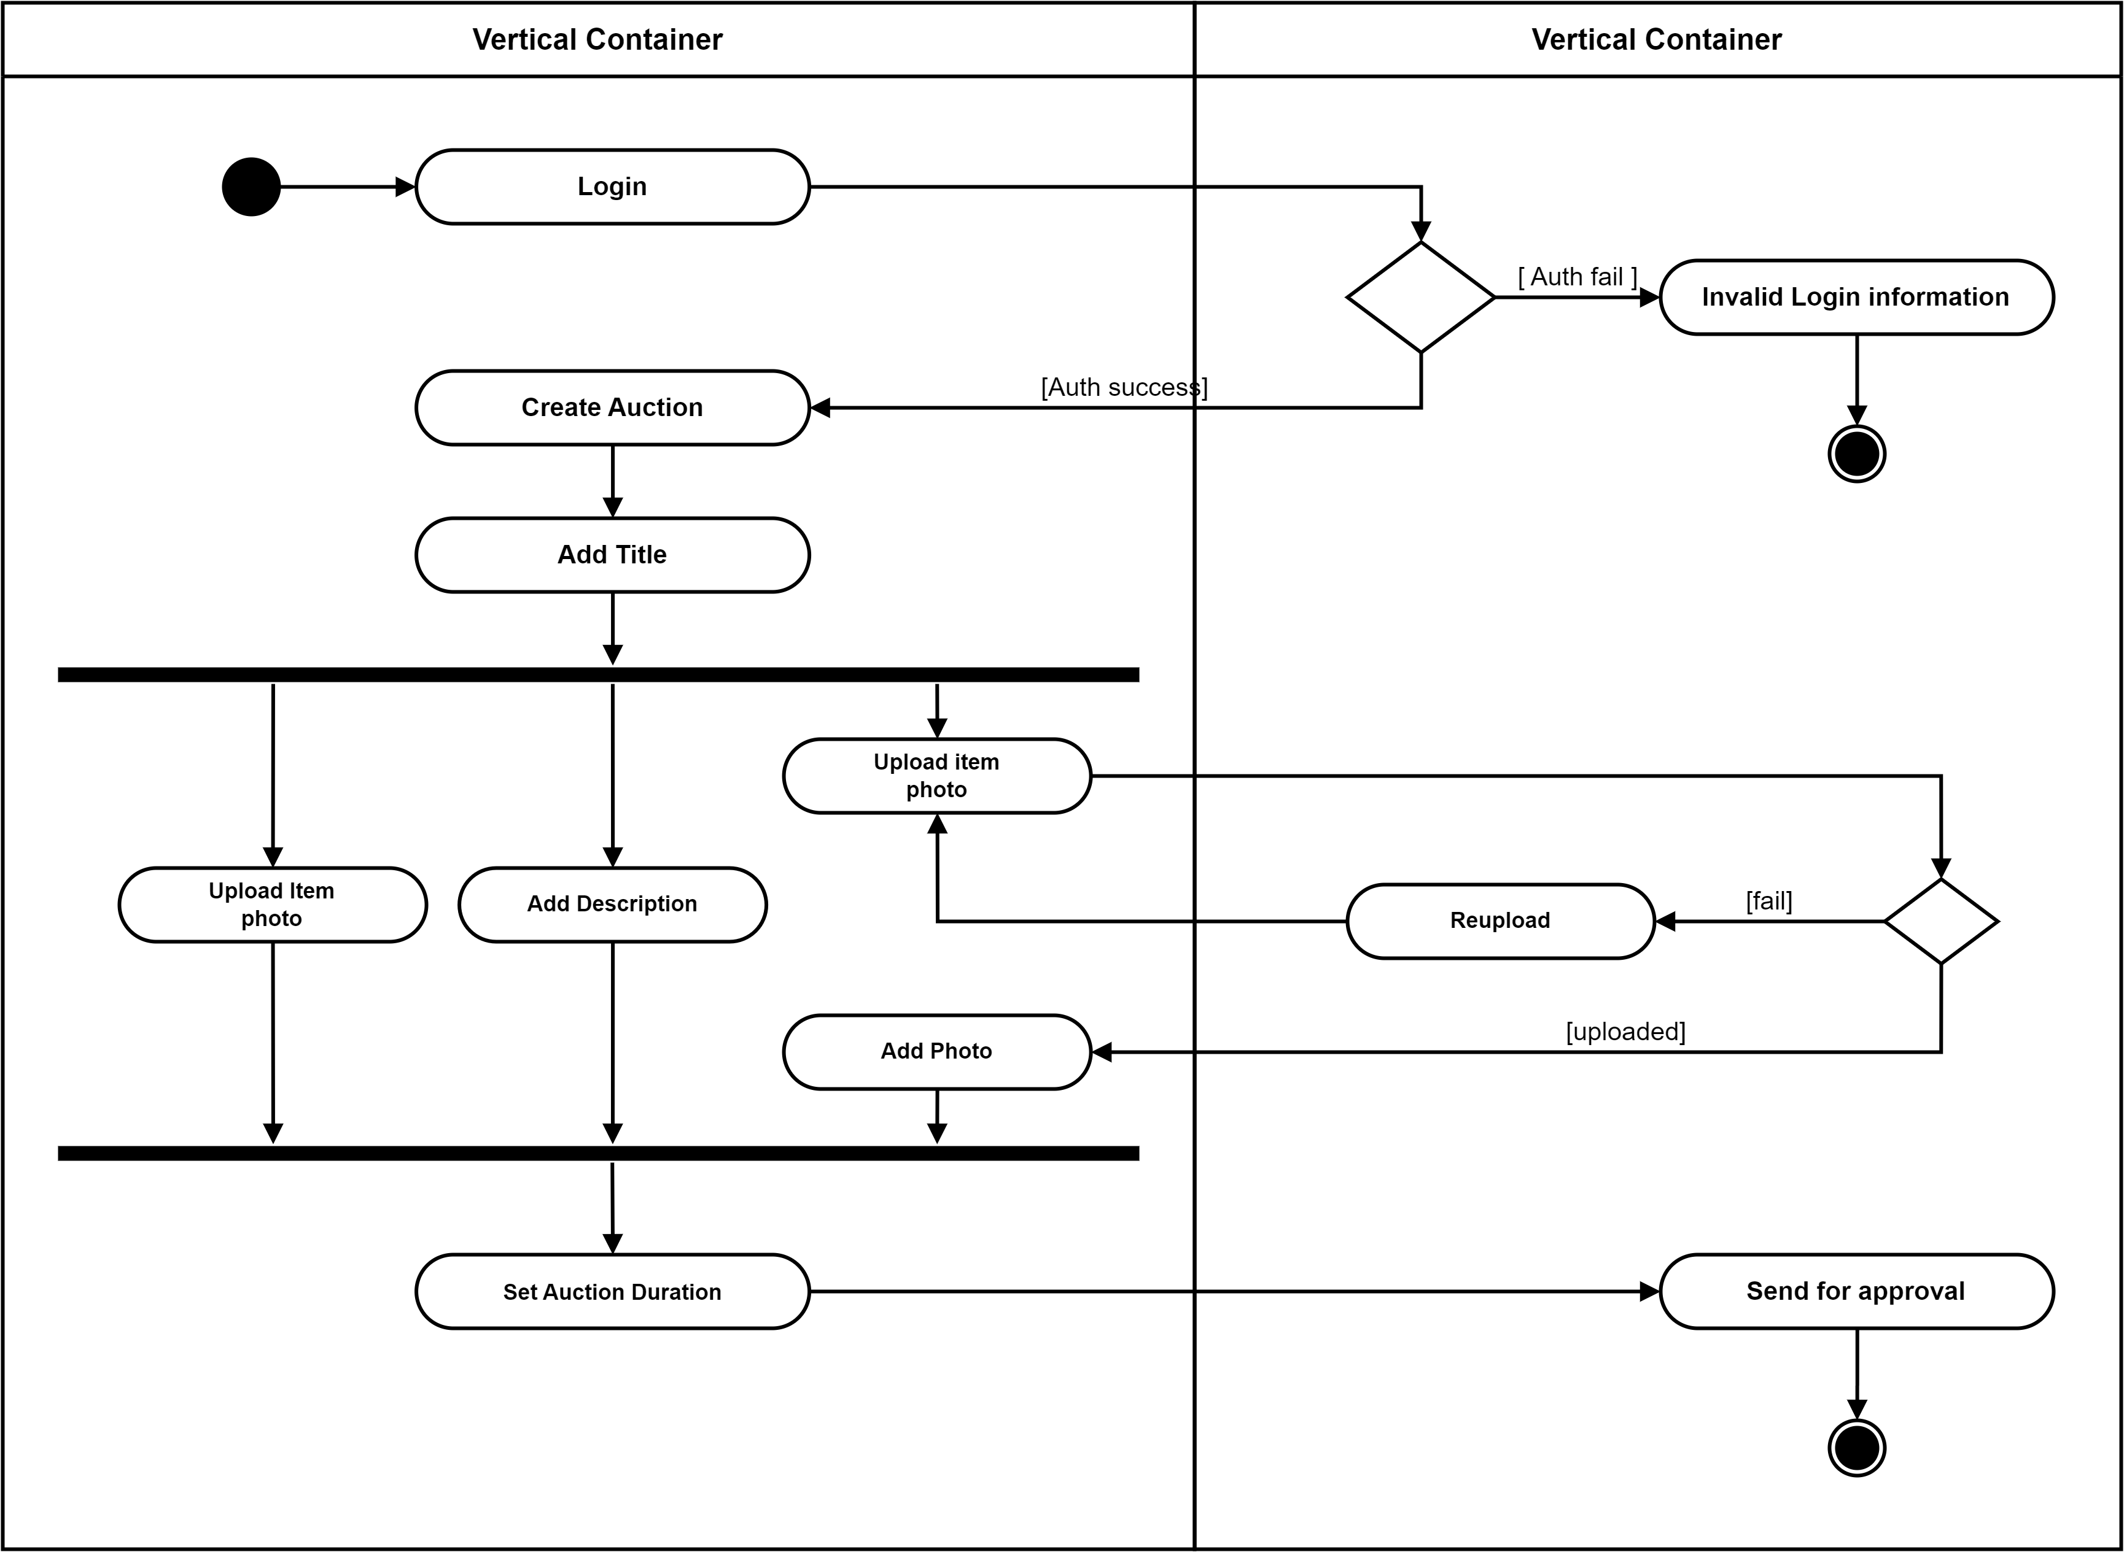

Figure 2.2.1-2 Swimlane diagram for Creating Auction

### Activity diagram for Placing a Bid

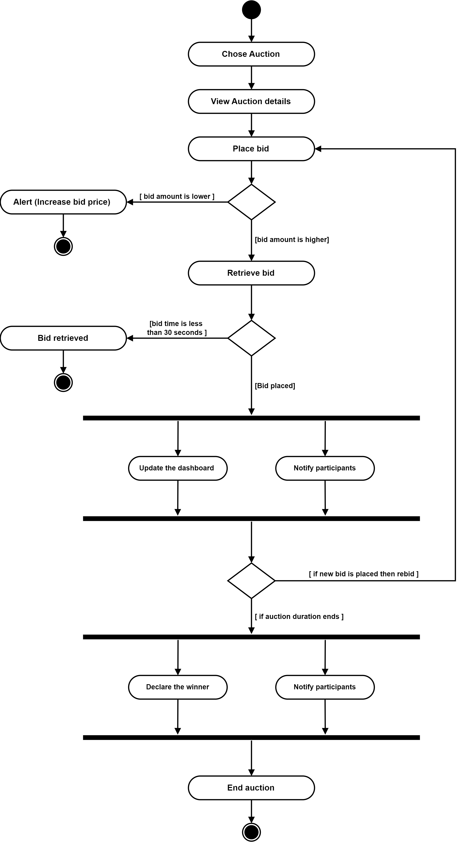

Figure 2.2.2 Activity diagram for Placing a Bid

## Sequence diagram

### Sequence diagram for Creating Auction

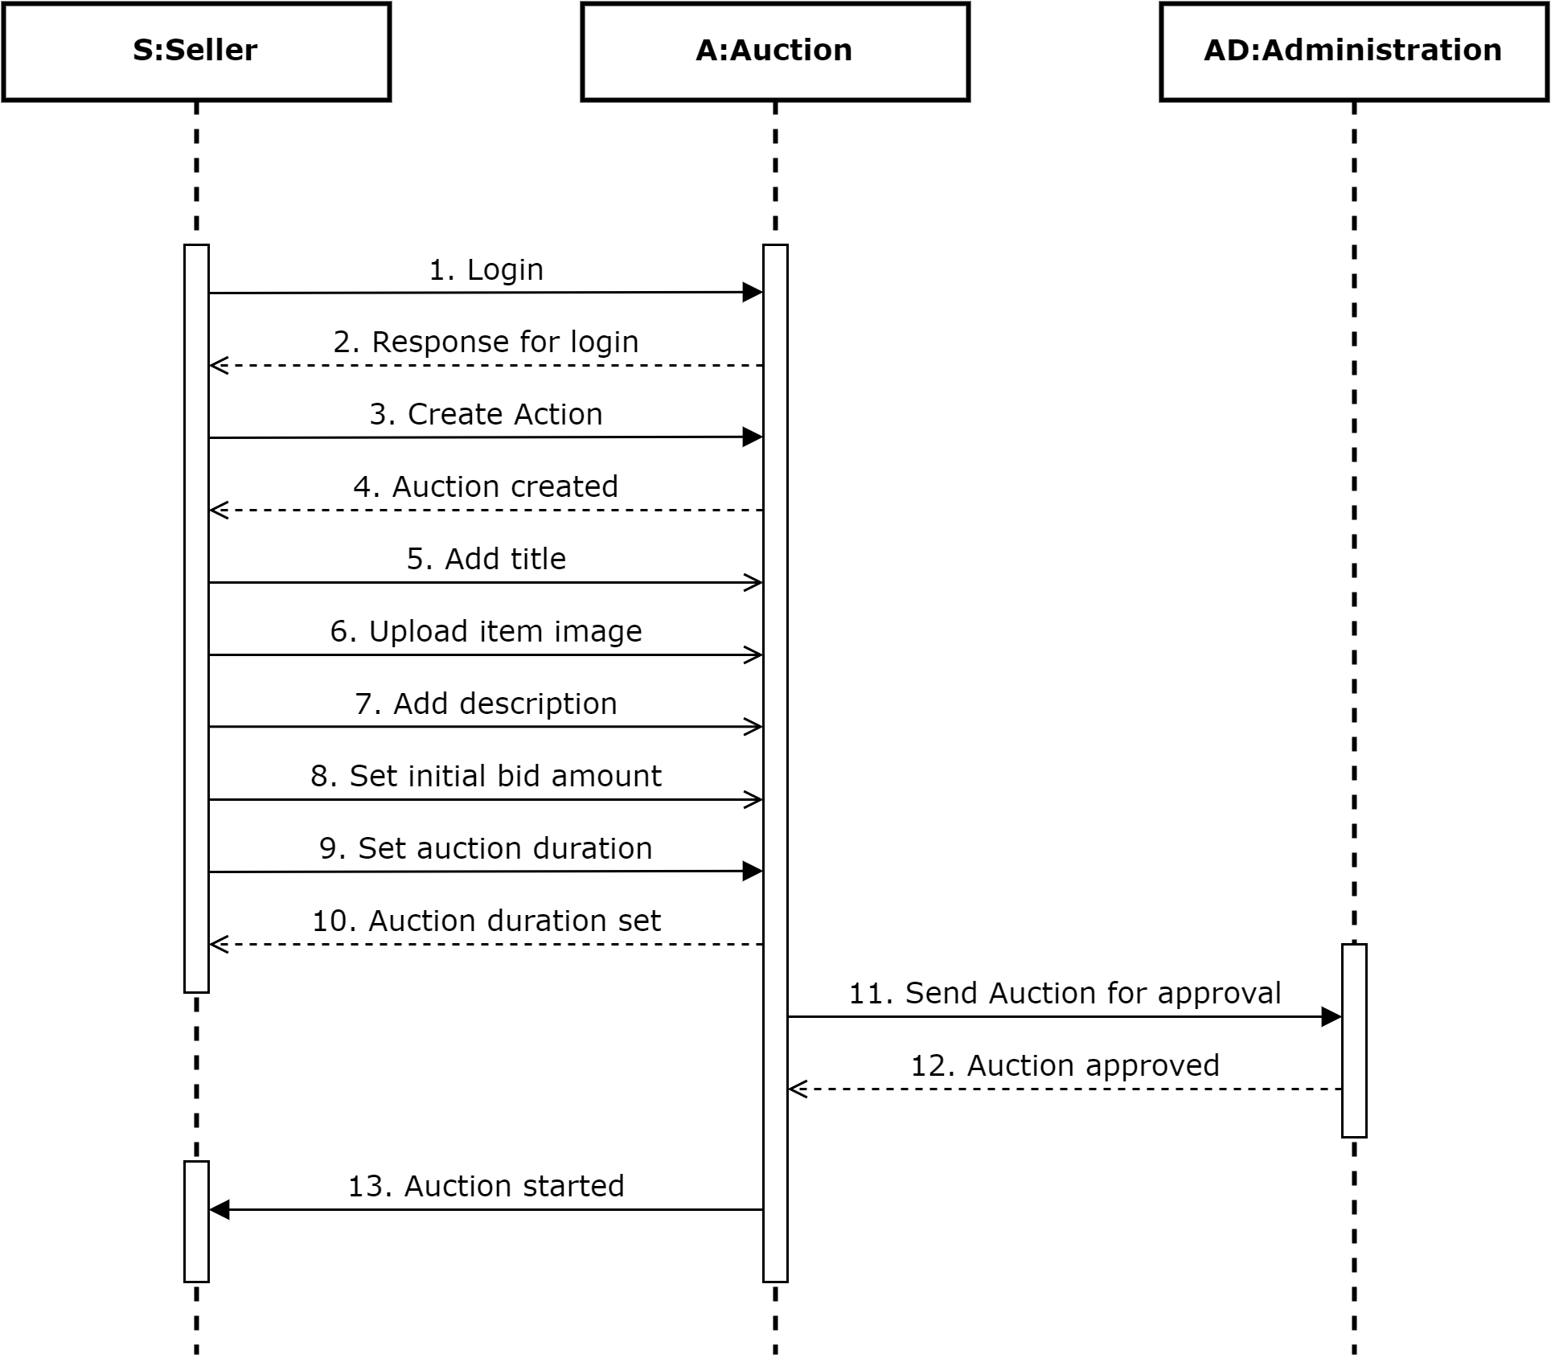

Figure 2.3.1 Sequence diagram for Creating Auction

### Sequence diagram for Searching Auctions and Placing a Bid

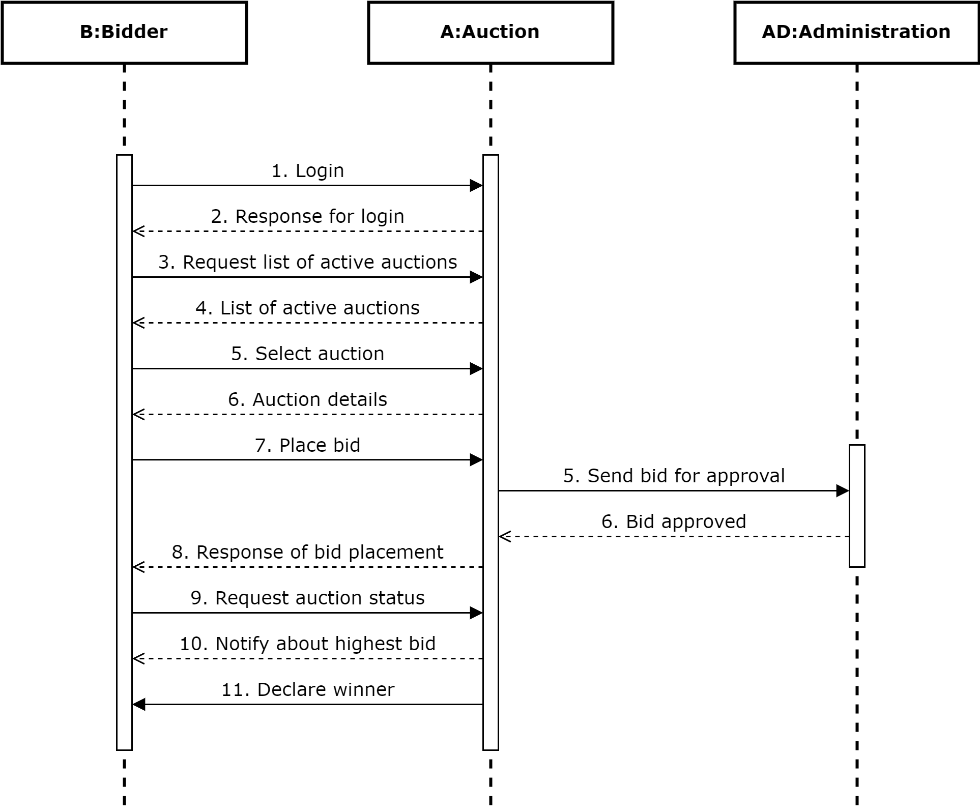

Figure 2.3.2 Searching Auctions and Placing a Bid

## State diagram

### State diagram of Auction

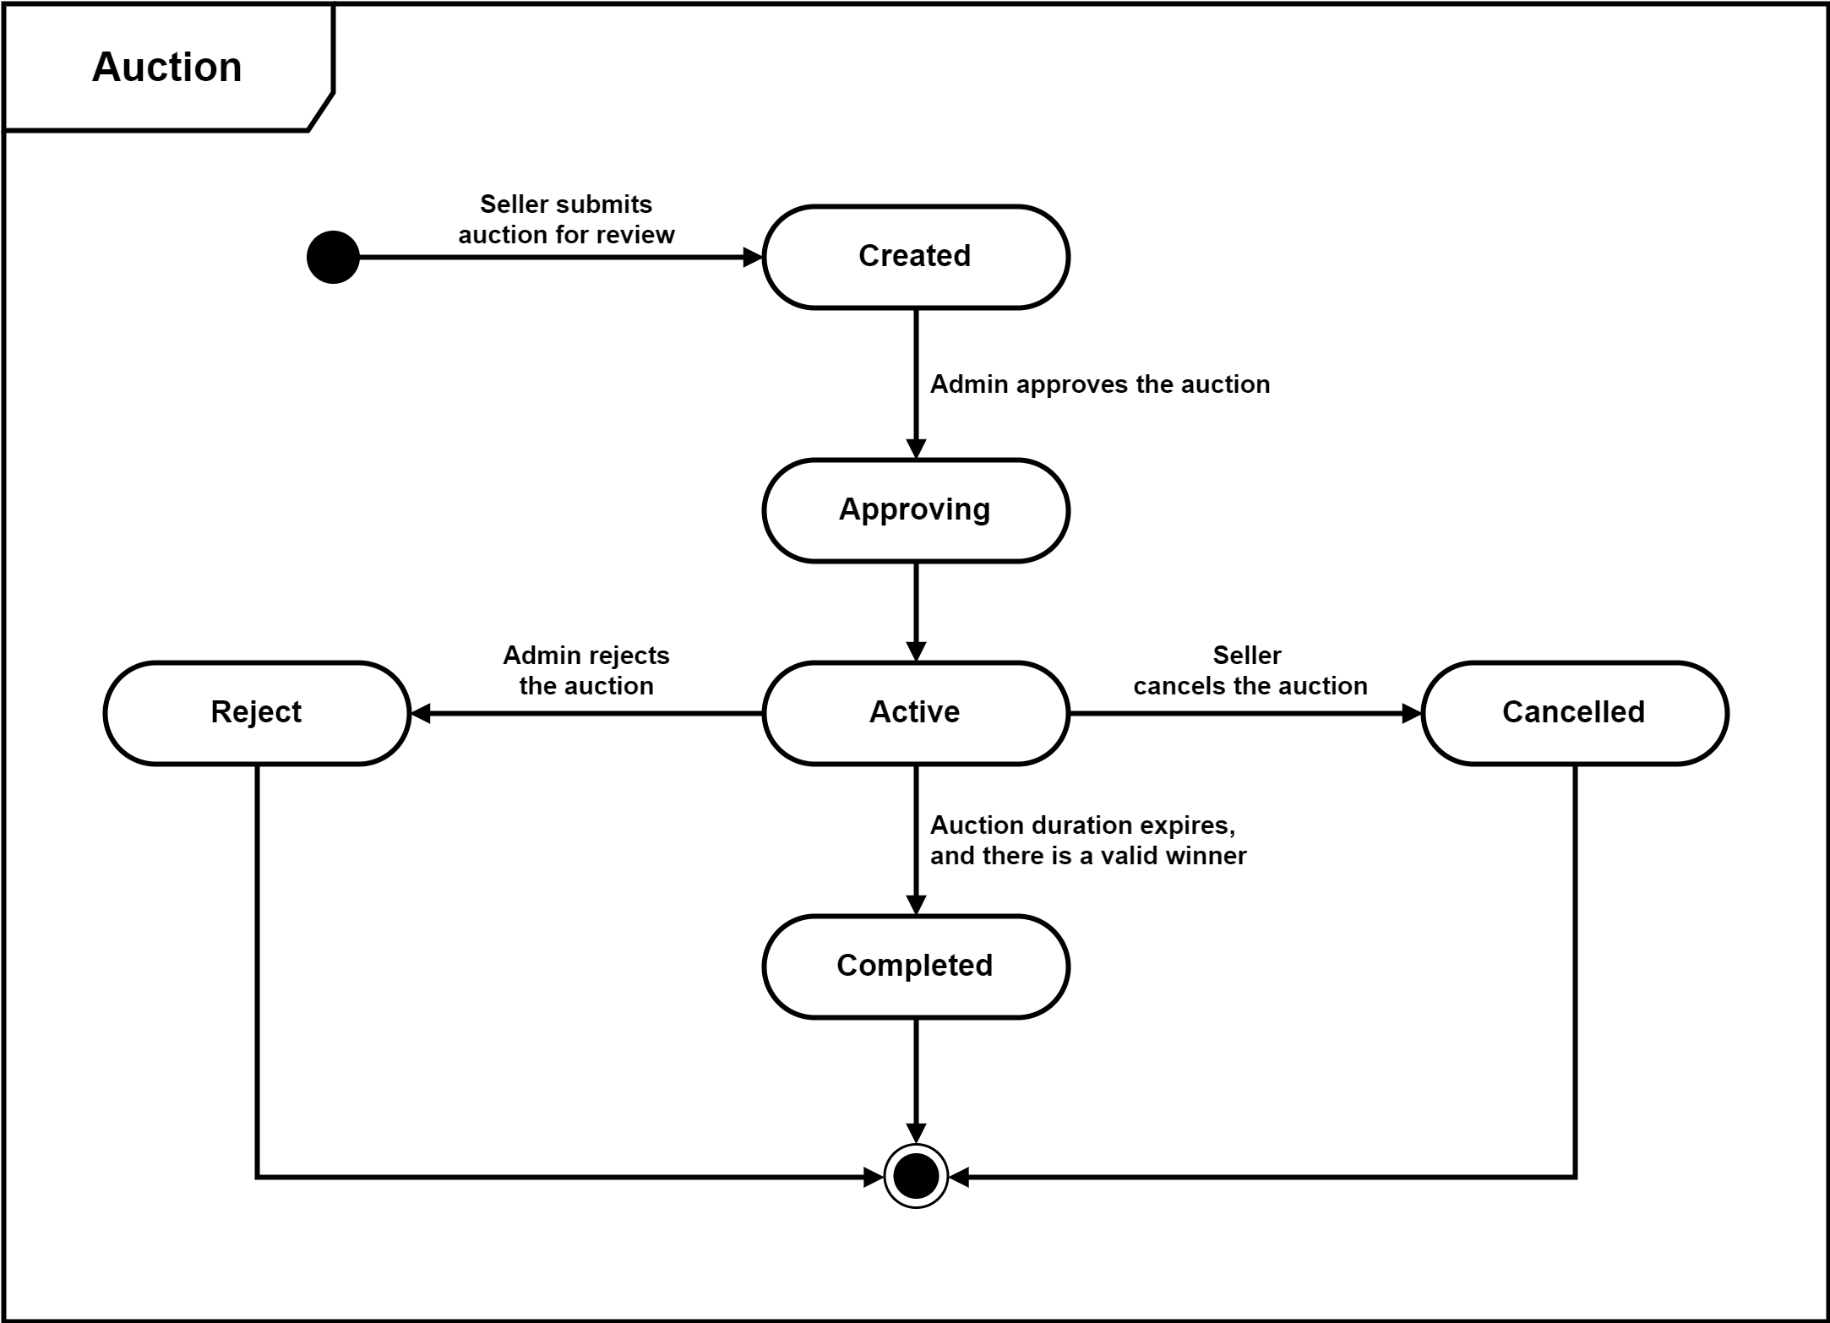

Figure 2.4.1 State diagram of Auction

### State diagram of Bid

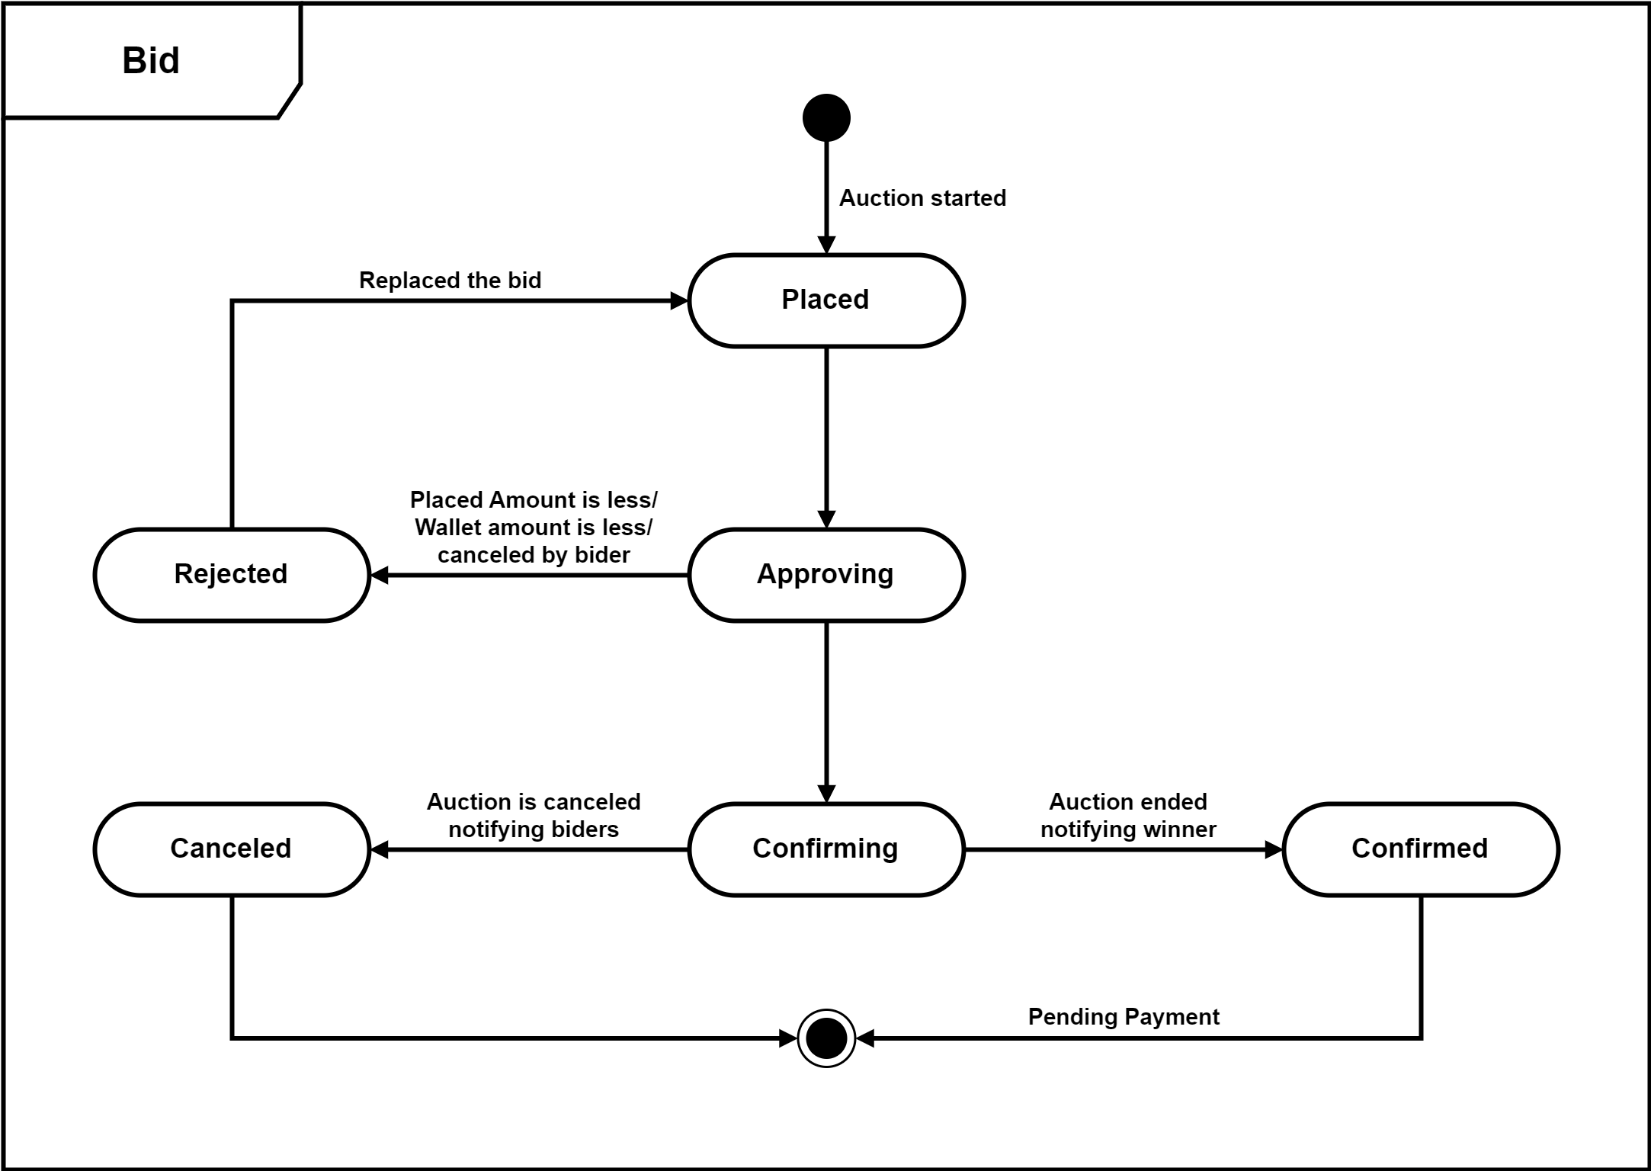

Figure 2.4.2 State diagram of Bid

## Class diagram

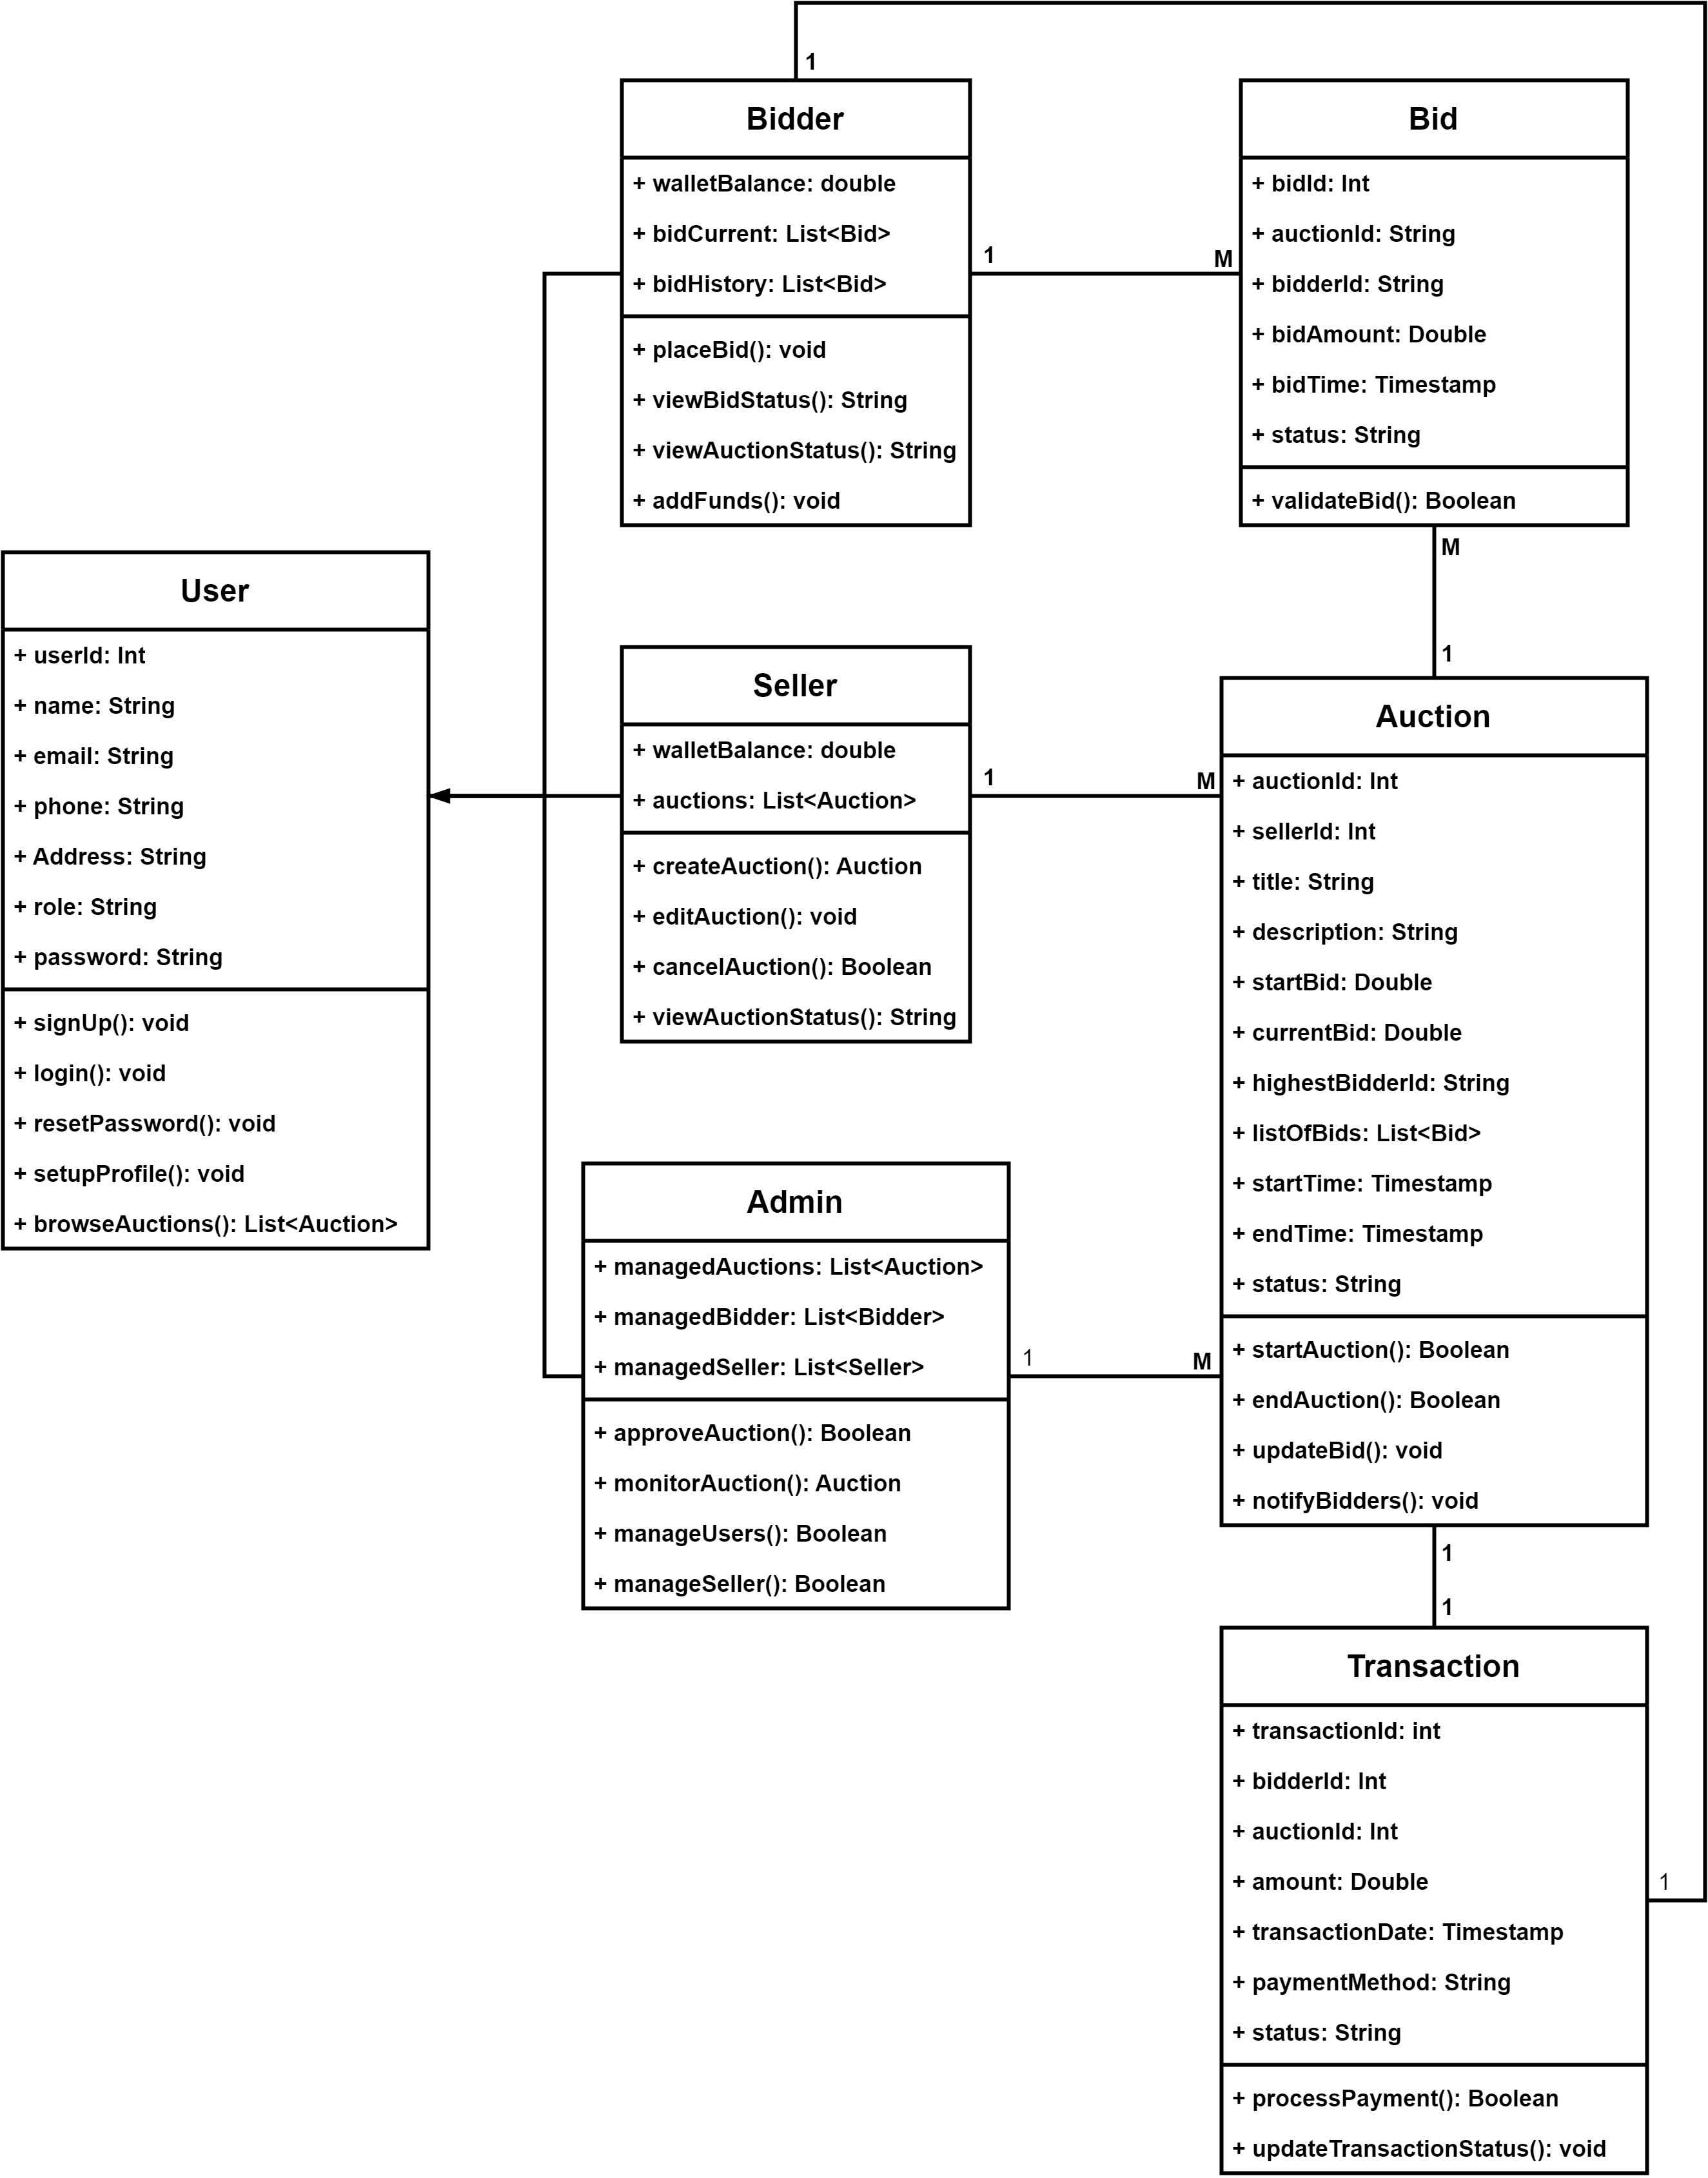

Figure 2.5 Class diagram for Auction Management System

## Data flow diagram

### Context diagram (level-0)

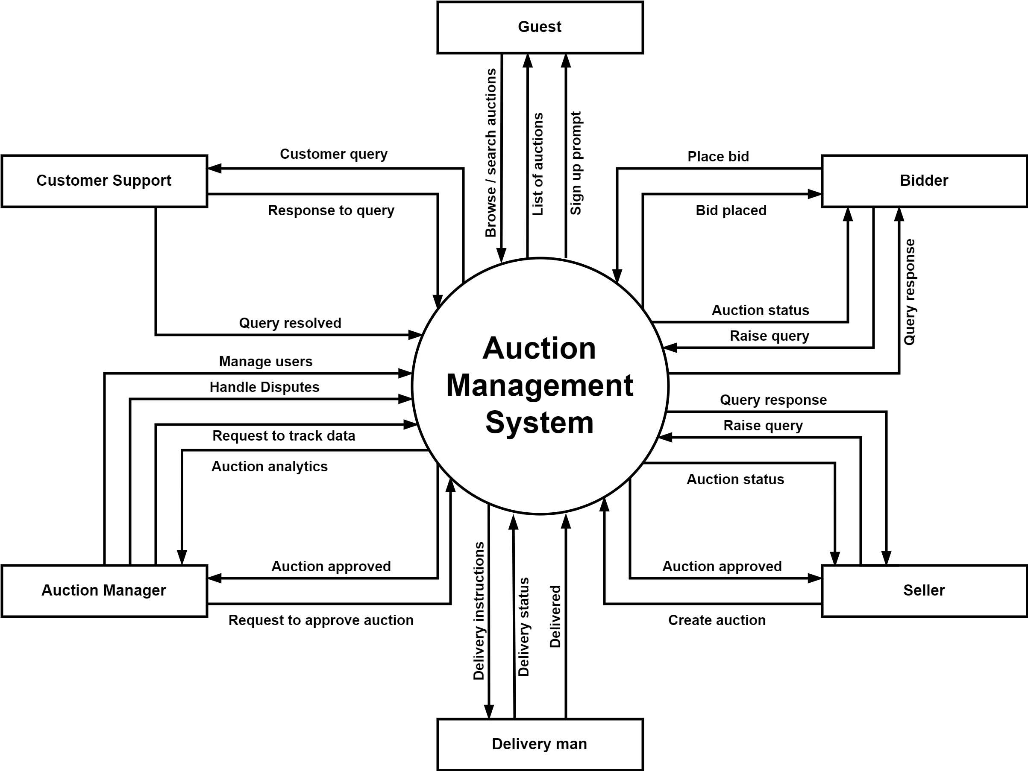

Figure 2.6.1 Context diagram (level-0) for Auction Management System

### DFD Level-1

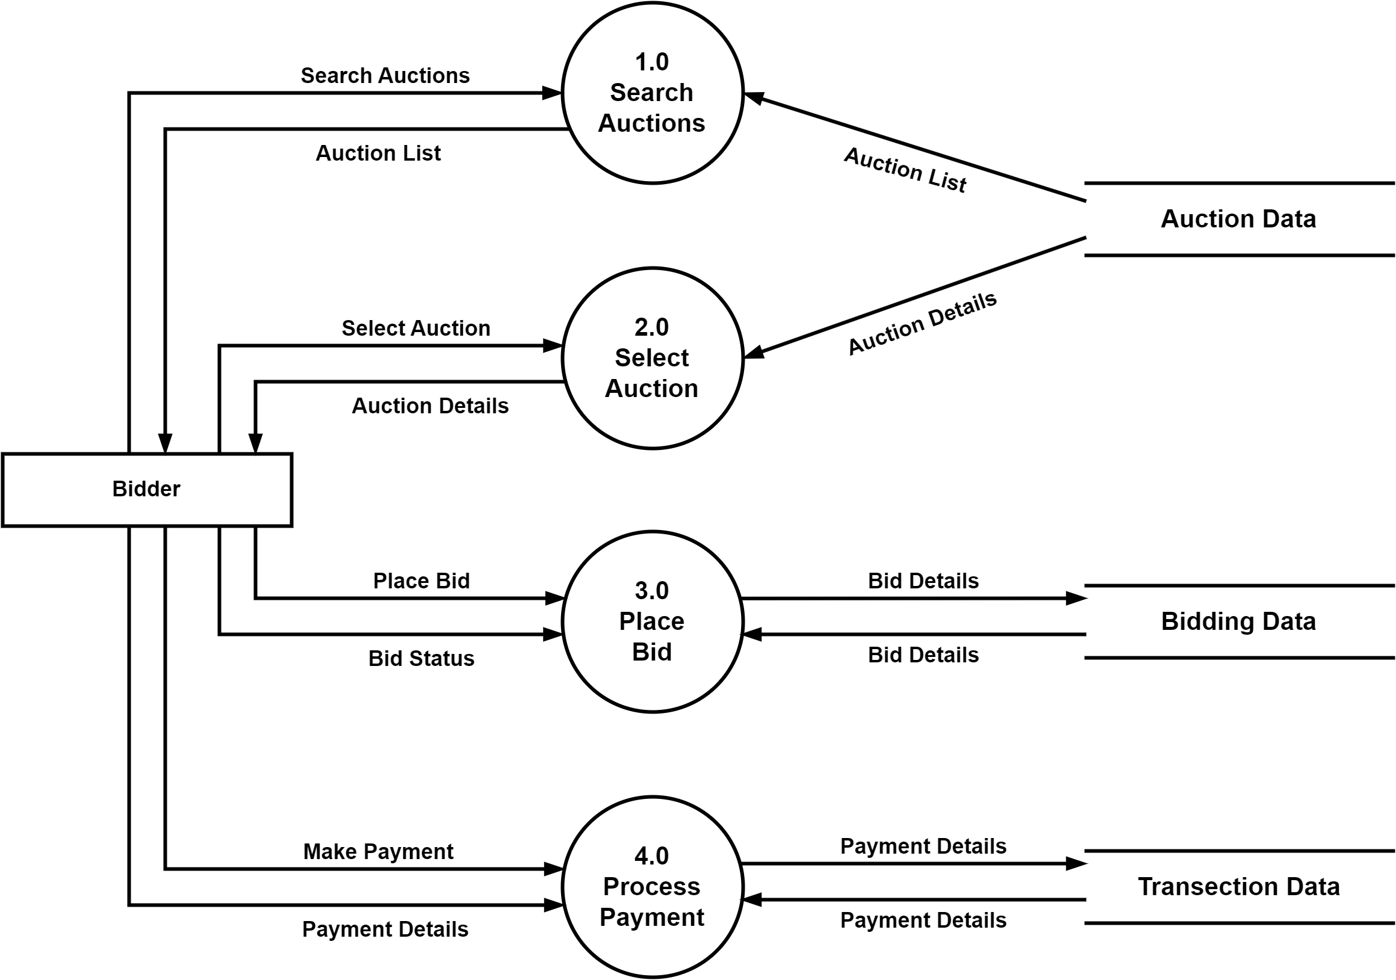

Figure 2.6.2 Data flow diagram level-1 for Auction Management System

### DFD Level-2

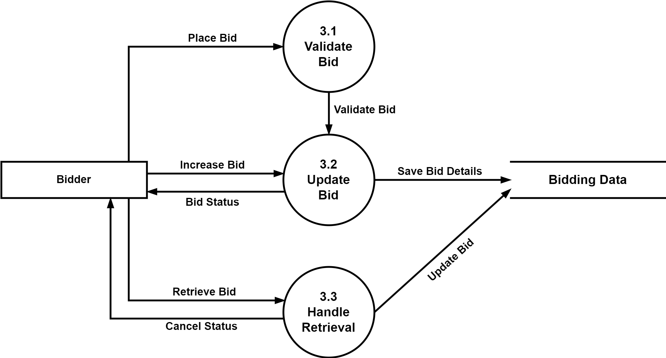

Figure 2.6.3 Data flow diagram level-2 for Auction Management System

# External interface requirement (Screens)

## Screen-1: Auction Listing

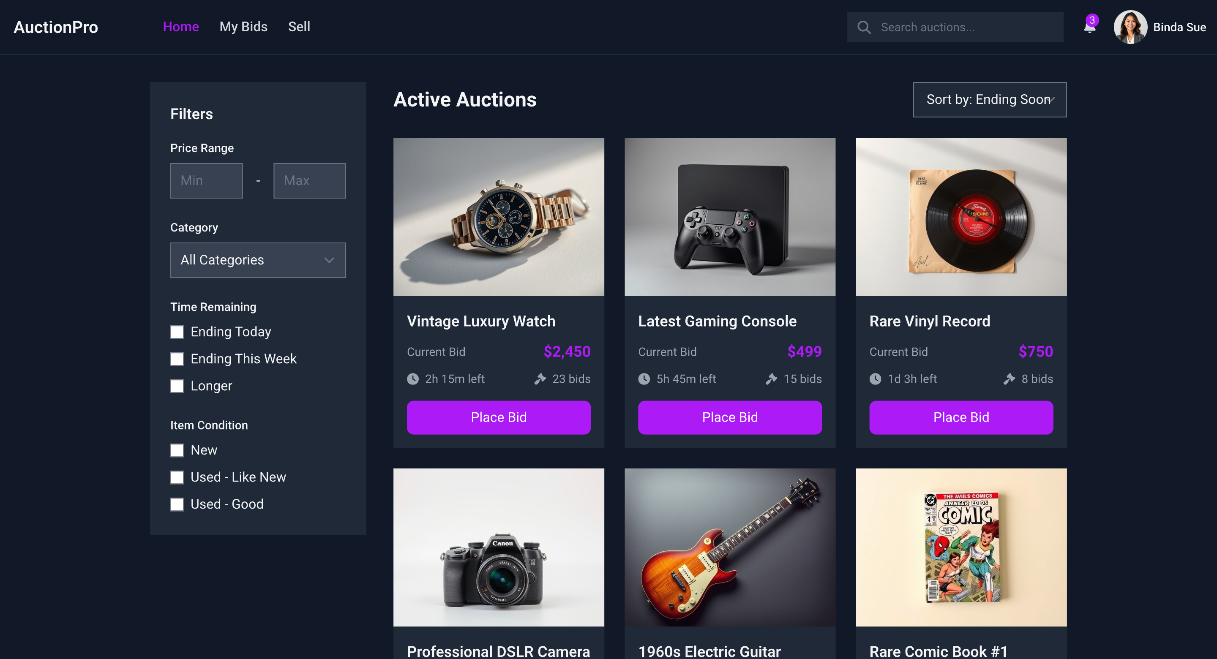

Figure 3.1 Screen-1: Auction Listing Page

**Purpose:** Displays all active and upcoming auctions with search and filter options, allowing users to explore auctions easily.

Table 3.1: Screen-1: Auction Listing Screen element of Auction Listing Page

|  |  |  |  |  |  |
| --- | --- | --- | --- | --- | --- |
| **Sr.** | **Screen Element** | **Input Type** | **O/M** | **1/N** | **Description** |
| **1** | Search Bar | Text Input | O | 1 | Allows users to search auctions by title, category, or seller. |
| **2** | Filter Dropdown | Dropdown | O | N | Enables filtering by category, price, and auction status. |
| **3** | Auction Cards | Interactive Card | M | N | Shows auction details (image, title, current bid, remaining time). |
| **4** | Place Bid Button | Button | M | 1 | Redirects users to the auction details page. |
| **5** | Pagination | Button | O | 1 | Allows users to navigate through multiple pages of auction listings. |

## Screen-2: Auction Details

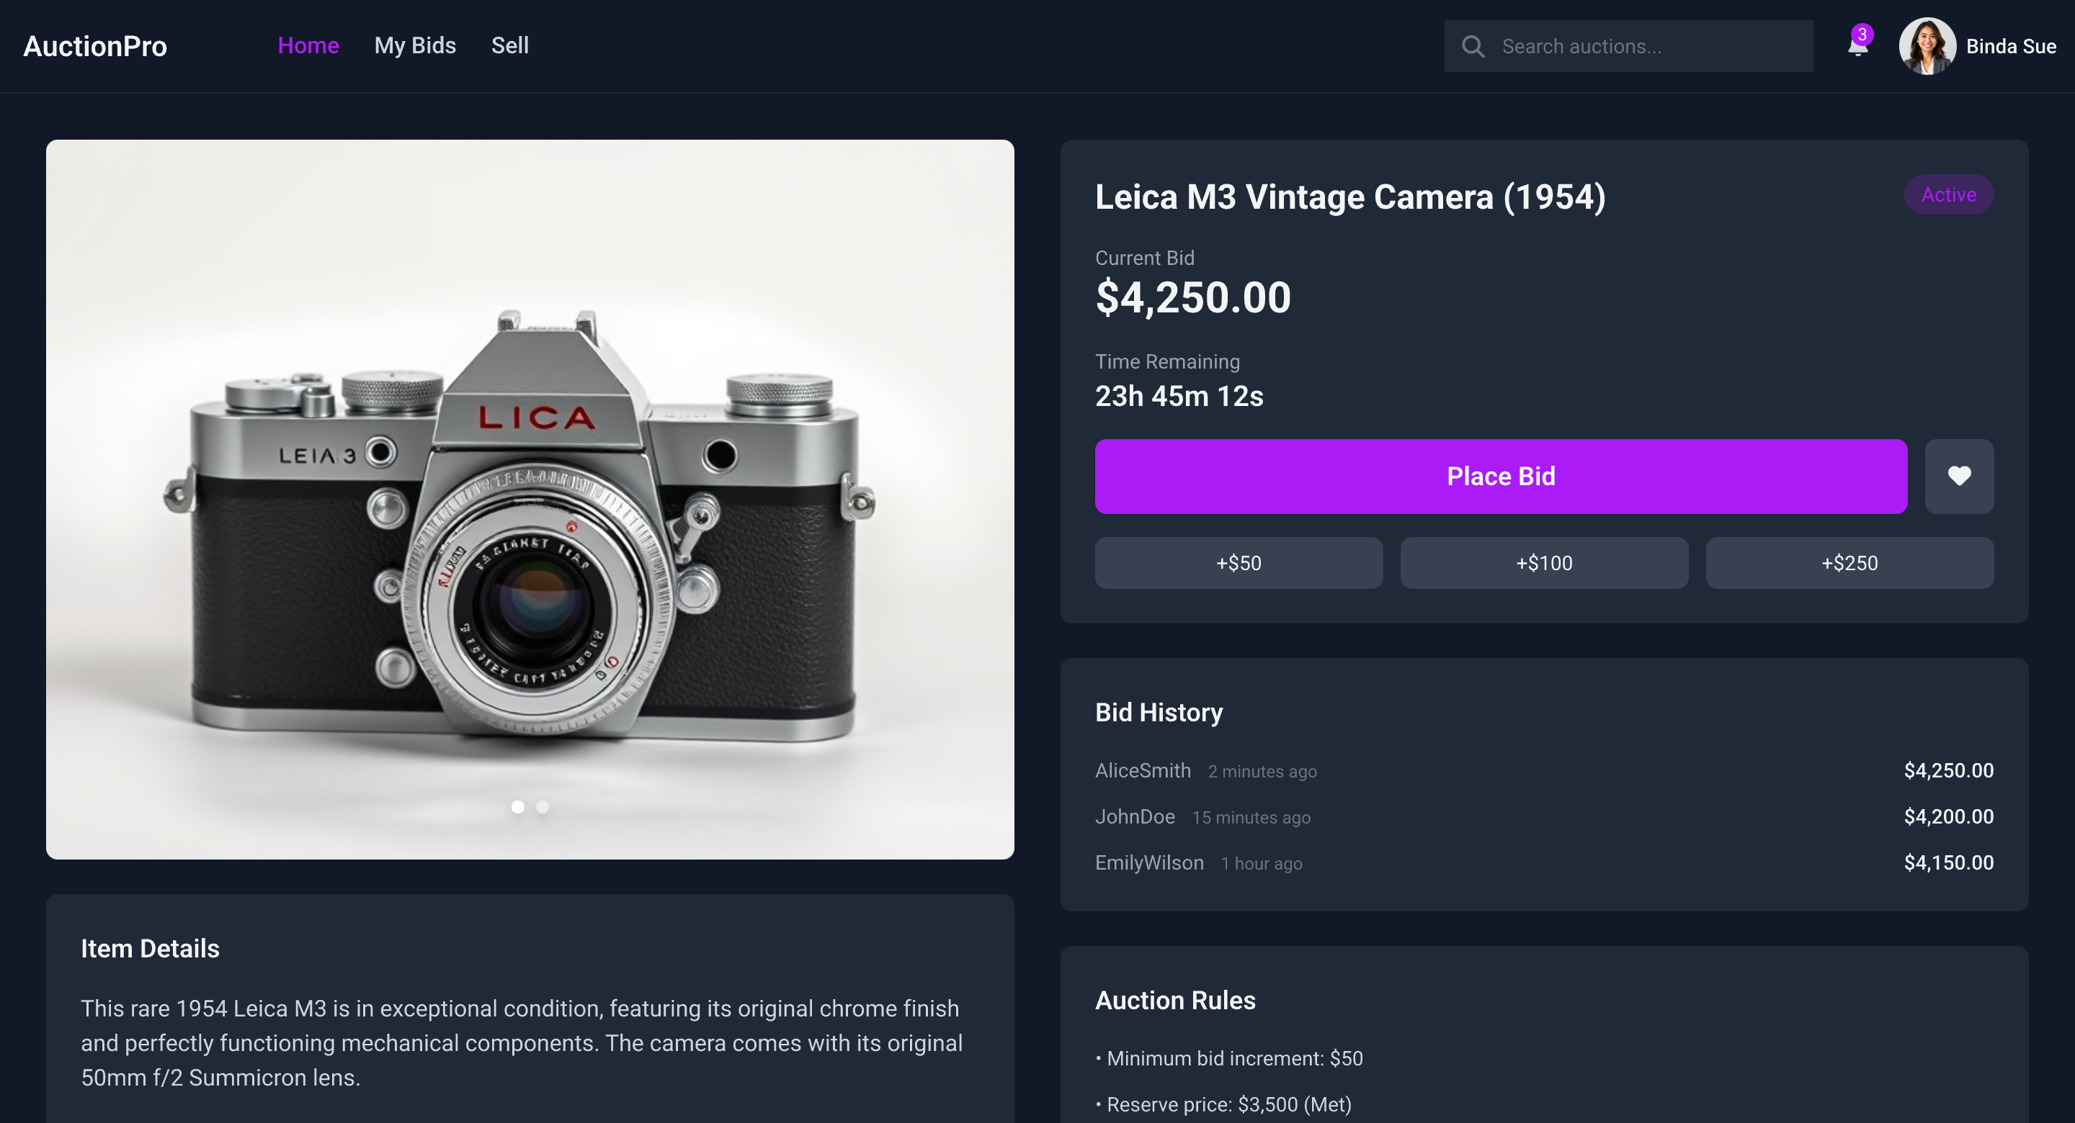

Figure 3.2 Screen-2: Auction Details Page

**Purpose:** Provides detailed information about a selected auction, including item description, bid history, and a bidding option for buyers.

Table 3.2: Screen-2: Auction Details Screen element of Auction Details Page

|  |  |  |  |  |  |
| --- | --- | --- | --- | --- | --- |
| **Sr.** | **Screen Element** | **Input Type** | **O/M** | **1/N** | **Description** |
| **1** | Auction Image Gallery | Display | M | N | Displays multiple images of the auction item. |
| **2** | Current Bid Display | Display | M | 1 | Shows the highest bid placed on the auction. |
| **3** | Bid Amount Input | Number Input | M | 1 | Allows the bidder to enter a new bid amount. |
| **4** | Place Bid Button | Button | M | 1 | Submits the entered bid amount. |
| **5** | Countdown Timer | Display | M | 1 | Shows the remaining time before the auction ends. |
| **6** | Bid History | Display | O | N | Displays the latest bids placed by users. |

## Screen-3: Bidder Dashboard

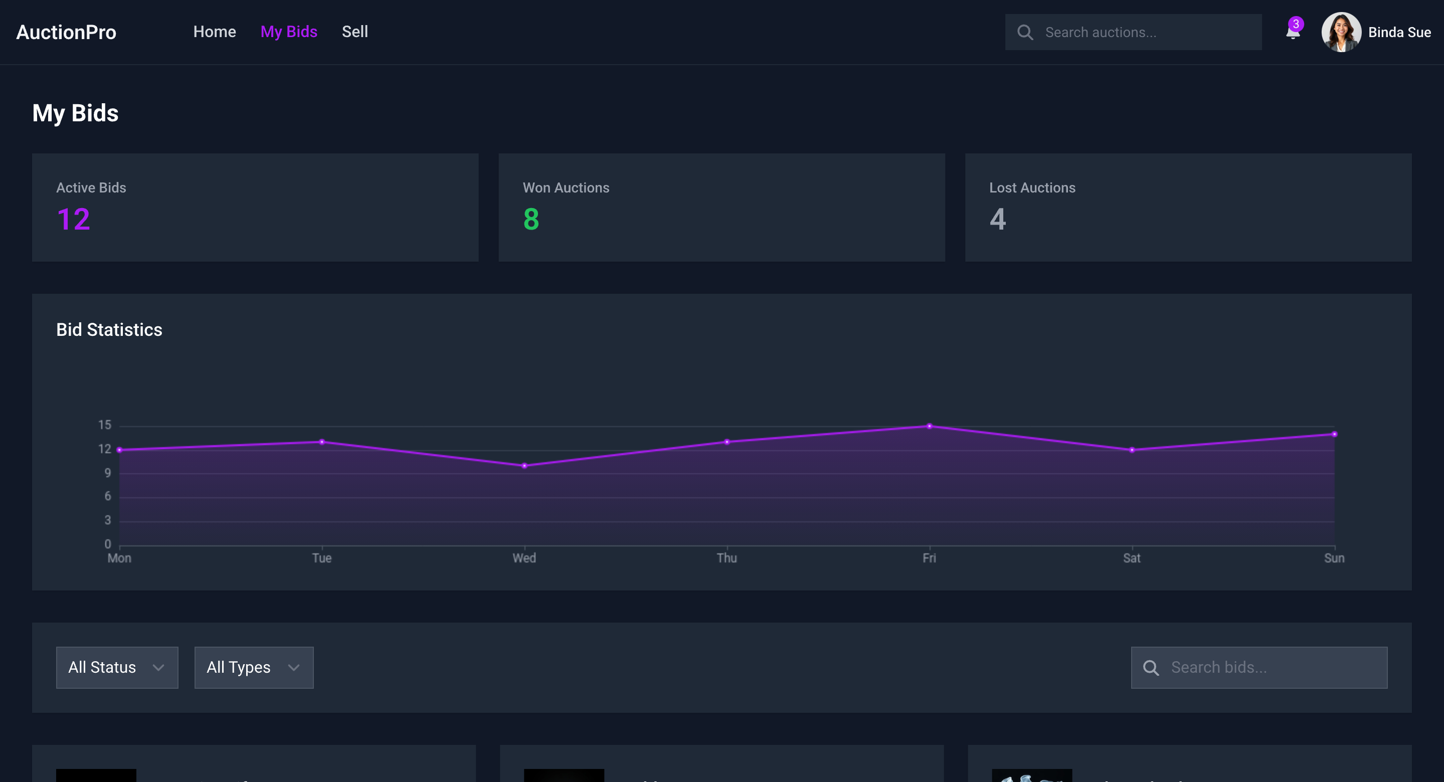

Figure 3.3 Screen-3: Bidder Dashboard

**Purpose:** Allows bidders to track their active, won, and lost bids while managing their auction-related activities.

Table 3.3: Screen-3: Bidder Dashboard Screen element of Bidder Dashboard

|  |  |  |  |  |  |
| --- | --- | --- | --- | --- | --- |
| **Sr.** | **Screen Element** | **Input Type** | **O/M** | **1/N** | **Description** |
| **1** | Active Bids Section | Display | M | N | Shows the list of auctions where the bidder has placed bids. |
| **2** | Won Auctions Section | Display | M | N | Displays auctions won by the bidder. |
| **3** | Outbid Notification | Dialogue | O | 1 | Alerts the bidder when they have been outbid. |
| **4** | Bid History | Display | O | N | Shows past bidding activity. |
| **5** | Profile Information | Inveterate Page | M | 1 | Shows the bidder’s details and allows profile updates. |

## Screen-4: Seller's Auction Creation Form

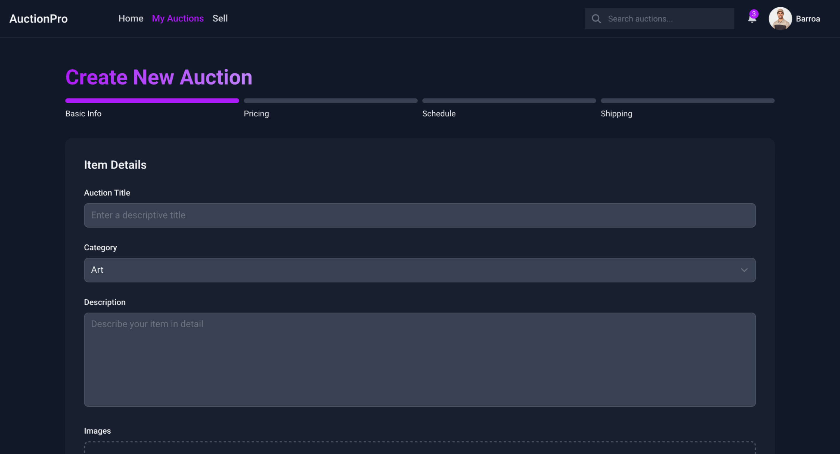

Figure 3.4 Screen-4: Seller's Auction Creation Form

**Purpose:** Provides administrators with tools to approve/reject auctions, monitor users, view reports, and manage disputes.

Table 3.4: Screen-4: Seller's Auction Creation Form Screen element of Seller's Auction Creation Form

|  |  |  |  |  |  |
| --- | --- | --- | --- | --- | --- |
| **Sr.** | **Screen Element** | **Input Type** | **O/M** | **1/N** | **Description** |
| **1** | Auction Title Input | Text Input | M | 1 | Allows the seller to enter a title for the auction. |
| **2** | Category Dropdown | Dropdown | M | 1 | Lets sellers select the appropriate auction category. |
| **3** | Starting Price Input | Number Input | M | 1 | Allows sellers to set the initial bid price. |
| **4** | Upload Images | File Upload | M | N | Sellers upload images of the item. |
| **5** | Auction Duration Picker | Date-Time Selector | M | 1 | Defines the auction start and end time. |
| **6** | Publish Button | Button | M | 1 | Submits the auction for admin review. |

## Screen-5: Admin Dashboard

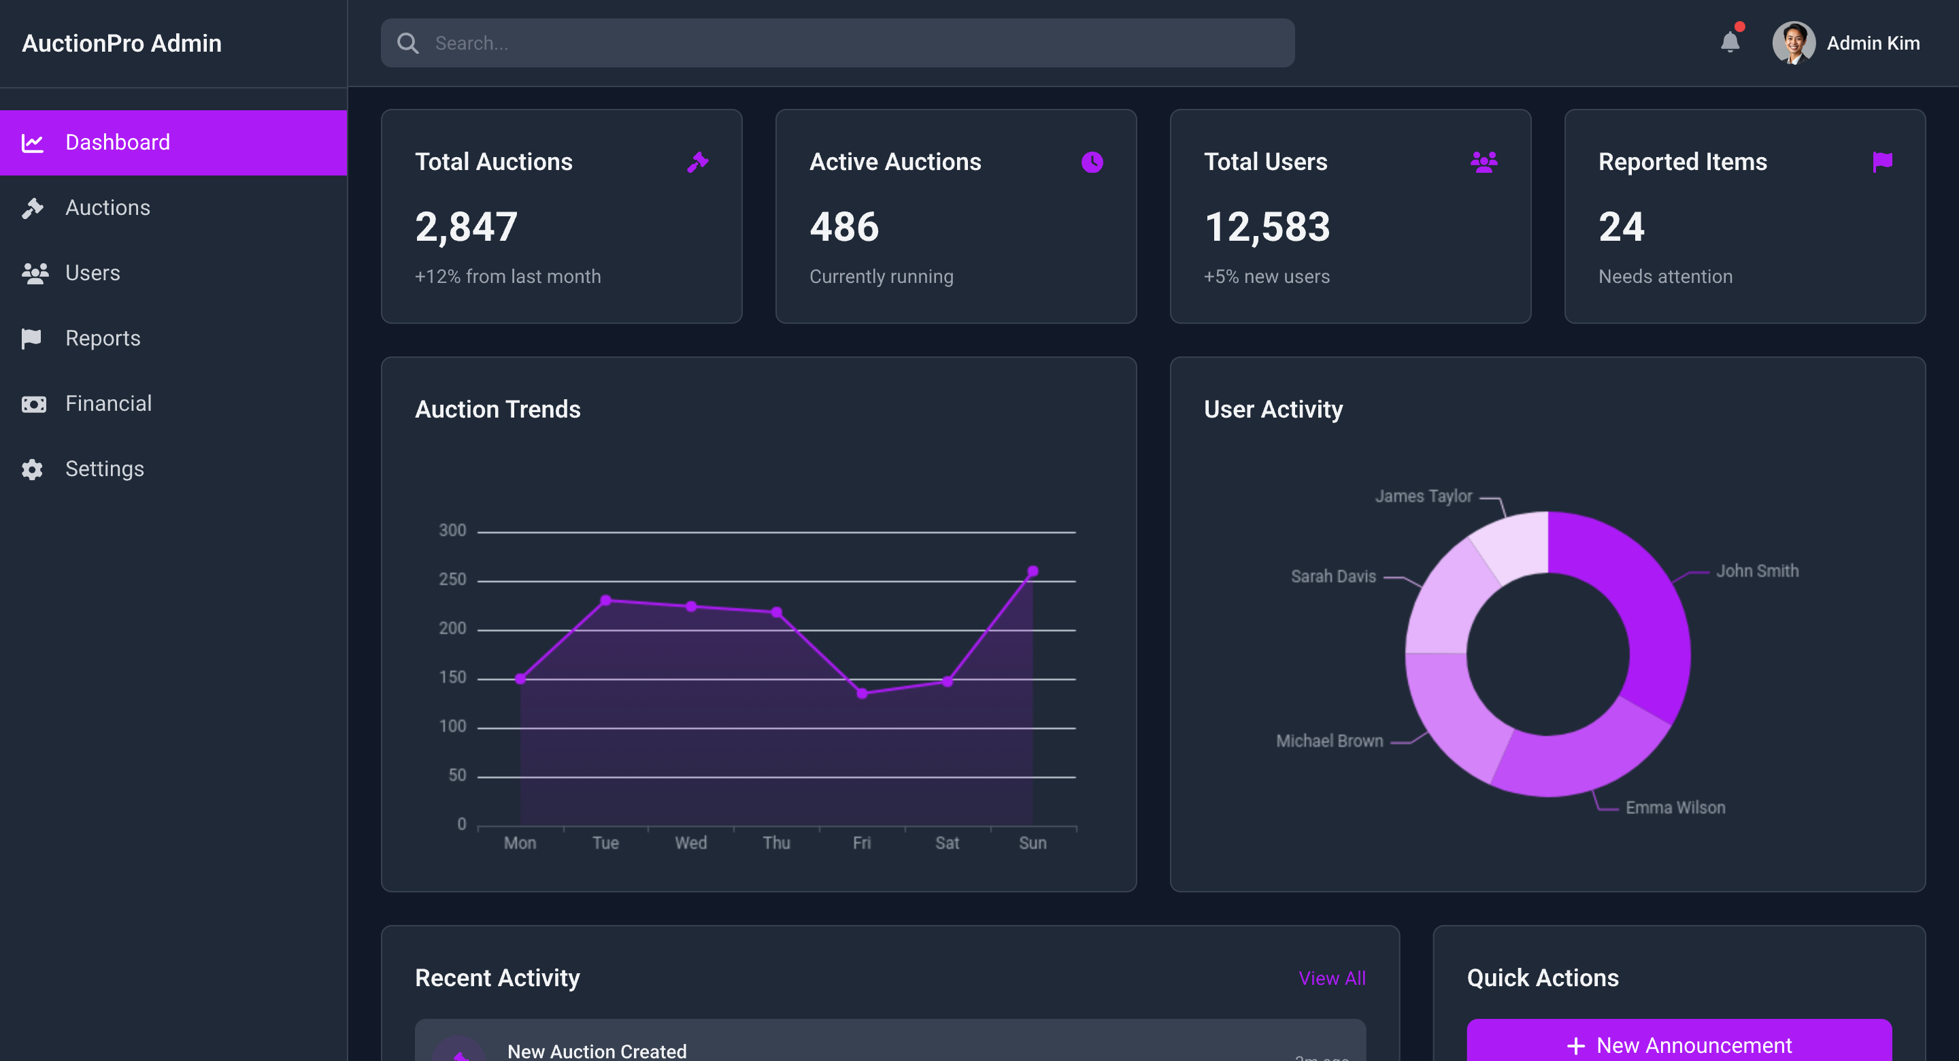

*Figure 3.5 Screen-5: Admin Dashboard*

**Purpose:** Provides administrators with tools to approve/reject auctions, monitor users, view reports, and manage disputes.

Table 3.5: Screen-5: Admin Dashboard Screen element of Admin Dashboard

|  |  |  |  |  |  |
| --- | --- | --- | --- | --- | --- |
| **Sr.** | **Screen Element** | **Input Type** | **O/M** | **1/N** | **Description** |
| **1** | Auction Approval List | Display | M | N | Shows auctions pending approval. |
| **2** | Approve Button | Button | M | 1 | Approves an auction for listing. |
| **3** | Reject Button | Button | M | 1 | Rejects an auction and notifies the seller. |
| **4** | User Management Section | Interactive Page | M | N | Allows admin to manage user accounts. |
| **5** | Reported Auctions Section | Display | M | N | Lists auctions flagged for violations. |
| **6** | System Logs | Display | M | N | Shows admin actions and system activity. |

# Database design

## List of Tables

* User
* Bidder
* Transaction
* Auction
* Bid

Table 4.1: Schema of User

|  |  |  |  |  |
| --- | --- | --- | --- | --- |
| **Column** | **Data Type** | **Null** | **Keys & Constrains** | **Default Value & Description** |
| **UserID** | int | NN | PK (Auto Increment) |  |
| **UserName** | varchar(100) | NN |  |  |
| **Email** | varchar(100) | NN | Unique |  |
| **Phone** | varchar(20) | NN | Unique |  |
| **Address** | varchar(200) | NN |  |  |
| **Role** | varchar(50) | NN | Check(‘User’,’Bidder’,  Seller) |  |
| **Password** | varchar(100) | NN |  |  |

Table 4.2: Schema of Bidder

|  |  |  |  |  |
| --- | --- | --- | --- | --- |
| **Column** | **Data Type** | **Null** | **Keys & Constrains** | **Default Value & Description** |
| **BidderID** | int | NN | PK (Auto Increment) |  |
| **UserID** | int | NN | FK | Reference of Users Table |
| **WalletBalance** | double | NN | Check(WalletBalance ≥ 0) |  |

Table 4.3: Schema of Transaction

|  |  |  |  |  |
| --- | --- | --- | --- | --- |
| **Column** | **Data Type** | **Null** | **Keys & Constrains** | **Default Value & Description** |
| **TransactionID** | int | NN | PK (Auto Increment) |  |
| **BidderID** | int | AN | FK | Reference of Seller Table |
| **AuctionID** | int | NN | FK | Reference of Auction Table |
| **Amount** | double | NN | Check(Amount ≥ 0) |  |
| **TransactionDate** | timestamp | NN |  |  |
| **PaymentMethod** | varchar(50) | NN | Check(‘Cod’,’Net-banking’,’UPI’,’Card’,’Cheque’) |  |

Table 4.4: Schema of Auction

|  |  |  |  |  |
| --- | --- | --- | --- | --- |
| **Column** | **Data Type** | **Null** | **Keys & Constrains** | **Default Value & Description** |
| **AuctionID** | int | NN | PK (Auto Increment) |  |
| **SellerID** | int | NN | FK | Reference of Seller Table |
| **Title** | varchar(100) | NN |  |  |
| **Description** | varchar(800) | NN |  |  |
| **StartBid** | double | NN | Check(StartBid ≥ 0) |  |
| **CurrentBid** | double | NN | Check(CurrentBid ≥ 0) |  |
| **HighestBidderId** | int | AN | FK | Reference of Bidder Table |
| **StartTime** | Timestamp | NN |  |  |
| **EndTime** | Timestamp | NN |  |  |
| **Status** | varchar(50) | NN | Check(‘Active’,’Inactive’,’Ended’) |  |

Table 4.5: Schema of Bid

|  |  |  |  |  |
| --- | --- | --- | --- | --- |
| **Column** | **Data Type** | **Null** | **Keys & Constrains** | **Default Value & Description** |
| **BidID** | int | NN | PK (Auto Increment) |  |
| **AuctionID** | int | NN | FK | Reference of Auction Table |
| **BidderId** | int | NN | FK | Reference of Bidder Table |
| **BidAmount** | double | NN | Check(StartBid ≥ 0) |  |
| **BidTime** | Timestamp | NN |  |  |
| **Status** | varchar(50) | NN | Check(‘Placed’,’Highest’,’Retried’) |  |

# Stories and Scenario

## Story-1: Place a Bid on an Auction

|  |  |  |
| --- | --- | --- |
| *Story #* ***S1*** | **:** | **As a** Bidder,  **I want** **to** place a bid on an auctioned item,  **so that** I can participate in the auction and attempt to purchase the item. |
| **Priority** | **:** | High |
| **Estimate** | **:** | L |
| **Reason** | **:** | Bidders must be able to place bids easily for the auction system to function  effectively. |

### Scenario# S1.1

|  |  |  |
| --- | --- | --- |
| *Scenario#* ***S1.1*** | **:** | Placing a Bid with Valid Information |
| **Prerequisite** | **:** | The bidder is logged into the system and has a valid payment method. |
| **Acceptance Criteria** | **:** | **Given:**  The bidder is on the auction listing page.  **When:** The bidder selects an auction and enters a valid bid amount (higher than the current bid).  **Then:** The system records the bid, updates the auction page, and sends a confirmation notification. |

### Scenario# S1.2

|  |  |  |
| --- | --- | --- |
| *Scenario#* ***S1.2*** | **:** | Placing a Bid with an Invalid Amount |
| **Prerequisite** | **:** | The bidder is logged in. |
| **Acceptance Criteria** | **:** | **Given:** The bidder is on the auction listing page.  **When:** The bidder enters a bid lower than the current highest bid.  **Then:** The system displays an error message stating that the bid must be higher, and the bid is not placed. |

## Story-2: Create an Auction Listing

|  |  |  |
| --- | --- | --- |
| *Story #* ***S2*** | : | **As a** Seller,  **I want to** list an item for auction,  **So that** potential buyers can bid on it. |
| **Priority** | **:** | High |
| **Estimate** | **:** | L |
| **Reason** | **:** | Auctions are the core feature of the platform, and sellers must be able to list items smoothly. |

### Scenario# S2.1

|  |  |  |
| --- | --- | --- |
| *Scenario#* ***S2.1*** | **:** | Successfully Creating an Auction |
| **Prerequisite** | **:** | The seller is logged in. |
| **Acceptance Criteria** | **:** | **Given:**  The seller is on the "Create Auction" page.  **When:** The seller enters valid auction details and uploads item photos.  **Then:** The system publishes the auction, making it available for bidders. |

### Scenario# S2.2

|  |  |  |
| --- | --- | --- |
| *Scenario#* ***S2.2*** | **:** | Notifying Seller of the Auction Winner While Logged Out |
| **Prerequisite** | **:** | The seller has an active auction that has ended. |
| **Acceptance Criteria** | **:** | **Given:** The seller is logged out of the system.  **When:** The auction ends and a winner is determined.  **Then:** The system sends a notification to the seller informing them of the auction winner. |

## Story-3: Approve an Auction Listing

|  |  |  |
| --- | --- | --- |
| *Story #* ***S3*** | **:** | **As an** Auction Manager,  **I want** **to** review and approve auction listings,  **so that** only valid auctions are made public. |
| **Priority** | **:** | Medium |
| **Estimate** | **:** | M |
| **Reason** | **:** | The system should prevent invalid or fraudulent listings from being published. |

### Scenario# S3.1

|  |  |  |
| --- | --- | --- |
| *Scenario#* ***S3.1*** | **:** | Approving a Valid Auction |
| **Prerequisite** | **:** | The auction manager is logged in. |
| **Acceptance Criteria** | **:** | **Given:** The manager is on the "Pending Auctions" dashboard.  **When:** The manager reviews an auction and approves it.  **Then:** The system marks the auction as approved, and the seller is notified. |

### Scenario# S3.2

|  |  |  |
| --- | --- | --- |
| *Scenario#* ***S3.2*** | **:** | Rejecting an Auction with Invalid Details |
| **Prerequisite** | **:** | The auction manager is logged in. |
| **Acceptance Criteria** | **:** | **Given:** The manager is on the "Pending Auctions" dashboard.  **When:** The manager finds missing or inappropriate auction details and rejects the listing.  **Then:** The system notifies the seller about rejection. |

# Test cases

|  |  |  |  |
| --- | --- | --- | --- |
| **Project Name:** | **Auction Management System** | **Test Designed by:** | **Dhruv R. Pithwa** |
| **Module Name:** | **Auction Listing** | **Test Designed date:** | 07-03-2025 |
| **Release Version:** | **1.0** | **Test Executed by:** | **R. B. Gondaliya** |
|  |  | **Test Execution date:** | 09-03-2025 |

|  |  |  |  |
| --- | --- | --- | --- |
| **Test Case ID** | **Test Title** | **Test Type** | **Description** |
| TC_001 | Create auction with valid details | Functional | Ensure that the seller can successfully create an auction with all required details. |
| TC_002 | Create auction with missing details | Functional | Verify that an error message appears when required fields are left empty. |

|  |  |
| --- | --- |
| **Test Case Title** | Create auction with valid details |
| **Test Type** | Functional |
| **Test Priority** | High |
| **Pre-condition** | Seller logged in. |

|  |  |  |  |  |  |  |  |
| --- | --- | --- | --- | --- | --- | --- | --- |
| **Test Step** | **Test Case Description** | **Expected Result** | **Actual Result** | **Status** | **Comment** | **Data** | **BUG ID** |
| 1 | Navigate to auction creation page | Page loads successfully | Page loaded successfully | Pass |  | Seller logged in |  |
| 2 | Enter valid auction details | Fields accept valid input | Data entered successfully | Pass |  | Title: "Vintage Watch"  Category:"Collectibles",  Price: "300000"  End Time: "24 |  |
| 3 | Upload valid auction images | Images uploaded successfully | Images uploaded | pass |  | Image format: .jpg, .png |  |
| 4 | Click "Create Auction" button | Auction is successfully created and listed | Auction created successfully | Pass |  |  |  |

|  |  |
| --- | --- |
| **Test Case Title** | Create auction with missing details |
| **Test Type** | Functional |
| **Test Priority** | High |
| **Pre-condition** | Incomplete form submission. |

|  |  |  |  |  |  |  |  |
| --- | --- | --- | --- | --- | --- | --- | --- |
| **Test Step** | **Test Case Description** | **Expected Result** | **Actual Result** | **Status** | **Comment** | **Data** | **BUG ID** |
| 1 | Navigate to auction creation page | Page loads successfully | Page loaded successfully | Pass |  | Seller logged in |  |
| 2 | Leave required fields empty and submit | Error message displayed | Error: "Please fill all required fields" | Pass |  | Title: ""  Category:"",  Price: ""  End Time: "" |  |
| 3 | Upload an unsupported image format | Error message displayed | Error: "Invalid file format" | Pass |  | Image format: .exe, .pdf |  |
| 4 | Click "Create Auction" button with errors | Auction is not created | Auction creation blocked | Pass |  |  |  |

|  |  |  |  |
| --- | --- | --- | --- |
| **Project Name:** | **Auction Management System** | **Test Designed by:** | **Dhruv R. Pithwa** |
| **Module Name:** | **Admin Dashboard** | **Test Designed date:** | 08-03-2025 |
| **Release Version:** | **1.0** | **Test Executed by:** | **R. B. Gondaliya** |
|  |  | **Test Execution date:** | 09-03-2025 |

|  |  |  |  |
| --- | --- | --- | --- |
| **Test Case ID** | **Test Title** | **Test Type** | **Description** |
| TC_003 | View auction statistics and user activity | Functional | Ensure that the admin dashboard displays auction trends, user activity, and reports correctly. |
| TC_004 | Reject a scam auction | Functional | Verify that the admin can identify and reject fraudulent auction listings. |

|  |  |
| --- | --- |
| **Test Case Title** | View auction statistics and user activity |
| **Test Type** | Functional |
| **Test Priority** | High |
| **Pre-condition** | Admin logged in. |

|  |  |  |  |  |  |  |  |
| --- | --- | --- | --- | --- | --- | --- | --- |
| **Test Step** | **Test Case Description** | **Expected Result** | **Actual Result** | **Status** | **Comment** | **Data** | **BUG ID** |
| 1 | Navigate to admin dashboard | Dashboard loads successfully | Dashboard loaded successfully | Pass |  | Admin logged in |  |
| 2 | View auction statistics and user activity | Data displayed correctly | Stats loaded correctly |  |  | Total Auctions: "50", Active: "30" |  |
| 3 | Filter auctions by status | Auctions filter correctly | Filter applied successfully |  |  | Status: "Completed" |  |
| 4 | Approve a pending auction | Auction is approved and listed | Auction approved successfully |  |  | Auction ID: "A123" |  |

|  |  |
| --- | --- |
| **Test Case Title** | Reject a scam auction |
| **Test Type** | Functional |
| **Test Priority** | High |
| **Pre-condition** | Fraudulent auction reported or flagged. |

|  |  |  |  |  |  |  |  |
| --- | --- | --- | --- | --- | --- | --- | --- |
| **Test Step** | **Test Case Description** | **Expected Result** | **Actual Result** | **Status** | **Comment** | **Data** | **BUG ID** |
| 1 | Navigate to admin dashboard | Dashboard loads successfully | Dashboard loaded successfully | Pass |  | Admin logged in |  |
| 2 | Open auction reports section | List of reported auctions displayed | Reports loaded correctly | Pass |  | Total Reports: "10" |  |
| 3 | Select a flagged auction | Auction details load for review | Scam auction details displayed | Pass |  | Auction ID: "SCM456" |  |
| 4 | Click "Reject Auction" button | Auction is removed from the active listings | Auction successfully rejected | Pass |  |  |  |
| 5 | Notify the seller about rejection | System sends rejection notification with reason | Seller receives rejection message | Pass |  | Seller ID: "S789" |  |

# References

* http://www.w3schools.com/html/html_intro.asp
* https://www.w3schools.com/php/default.asp
* https://www.javatpoint.com/uml